Baddi University's Green Campus Initiatives: Paving the Way for Sustainable Education 7.1.5
Introduction
Baddi University, a renowned institution of higher learning, is committed to fostering a sustainable environment and promoting eco-friendly practices within its campus. Understanding the impact of human activities on the environment, the university has taken significant strides towards establishing a green campus. Through a range of initiatives, Baddi University aims to reduce its carbon footprint, preserve natural resources, and inspire its community to adopt sustainable living practices.
Restricted Entry of Automobiles
One of the primary green campus initiatives at Baddi University is the restricted entry of automobiles on campus. This measure not only reduces vehicular emissions but also promotes a pedestrian-friendly environment, enhancing safety and reducing noise pollution. Designated parking areas are provided at the campus periphery to encourage students, faculty, and staff to park their vehicles and use alternative modes of transportation within the university premises.
Pedestrian-Friendly Pathways
The university has invested in creating well-designed pedestrian-friendly pathways that crisscross the campus. These pathways not only encourage walking and physical activity but also enhance connectivity between different academic buildings and facilities. These well-lit and landscaped pathways further contribute to a pleasant and green campus experience for students, faculty, and visitors alike.
Ban on Use of Plastic
Taking a firm stand against plastic pollution, Baddi University has implemented a comprehensive ban on the use of plastic materials on campus. Single-use plastic items, such as bags, bottles, and cutlery, have been replaced with eco-friendly alternatives like cloth bags, biodegradable utensils, and refillable water stations. This initiative has significantly reduced plastic waste generation, contributing to a cleaner and greener campus environment.
Landscaping with Trees and Plants
Baddi University believes in the importance of green spaces for not only environmental sustainability but also for promoting mental well-being and academic productivity. The campus is adorned with lush greenery, including a diverse range of trees and plants. Besides providing shade and improving air quality, these green spaces serve as recreational areas for students and faculty, fostering a connection with nature.
Waste Management and Recycling
The university has implemented a robust waste management system to ensure proper segregation and recycling of waste materials. Recycling bins are strategically placed across the campus, promoting responsible waste disposal. Additionally, awareness campaigns and workshops are organized to educate the university community about the importance of waste reduction and recycling.
Rainwater Harvesting and Water Conservation
Acknowledging the significance of water conservation in a region prone to seasonal variations, Baddi University has adopted rainwater harvesting techniques to recharge groundwater levels. Rainwater is collected and stored for later use, reducing the dependency on conventional water sources. Moreover, water-efficient fixtures and fittings are installed across the campus to minimize water wastage.
Conclusion
Baddi University's green campus initiatives exemplify its dedication to environmental sustainability and responsible stewardship of natural resources. Through the restricted entry of automobiles, encouragement of bicycles and battery-powered vehicles, pedestrian-friendly pathways, a ban on plastic, lush landscaping, and waste management and recycling efforts, the institution has set a remarkable example for creating a sustainable educational environment. By instilling a sense of environmental consciousness in its students, faculty, and staff, Baddi University ensures that its community plays an active role in safeguarding the planet for future generations. As a beacon of sustainability in the education sector, Baddi University continues to inspire other institutions to follow suit and contribute to a greener and more sustainable world.

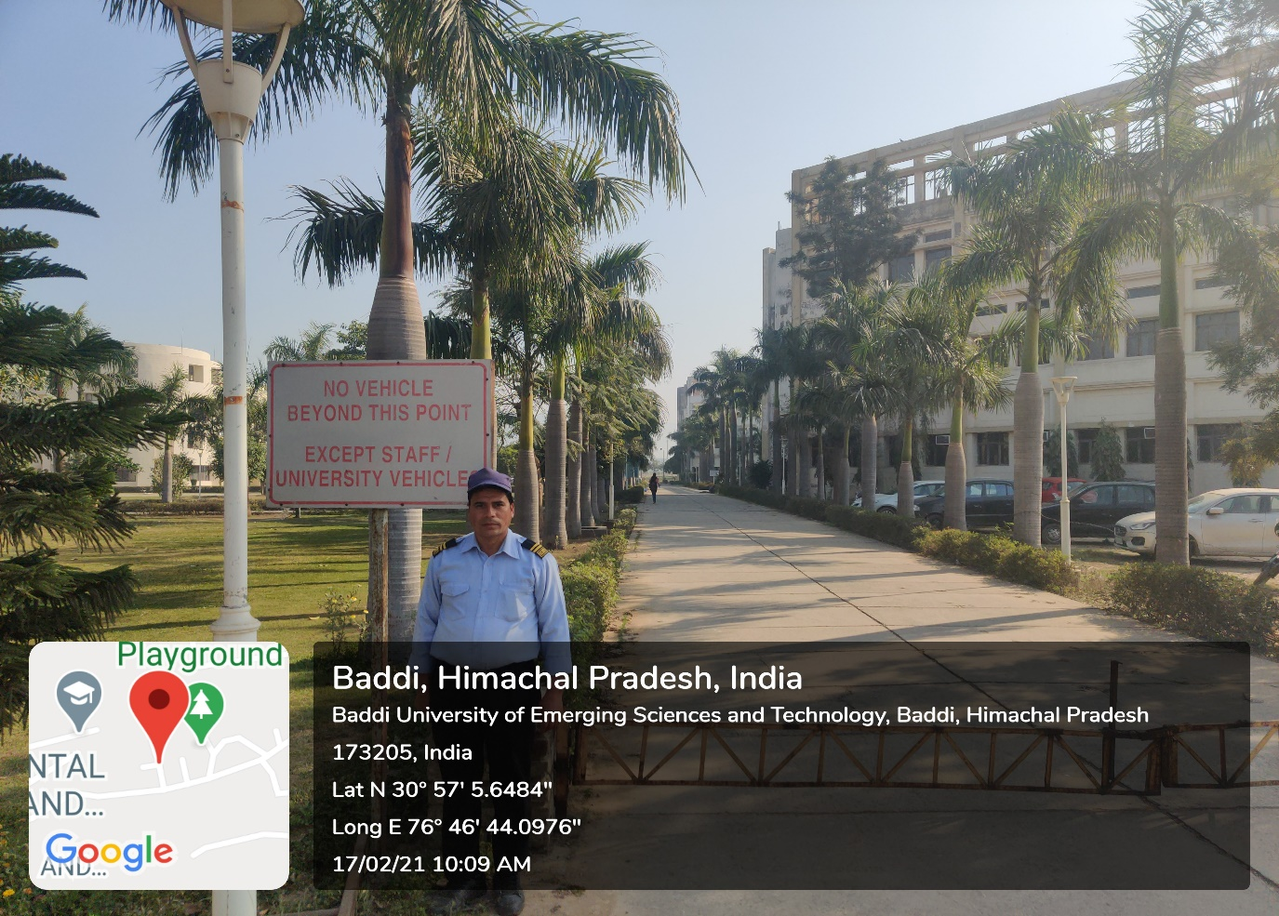

- Pedestrian Friendly pathways
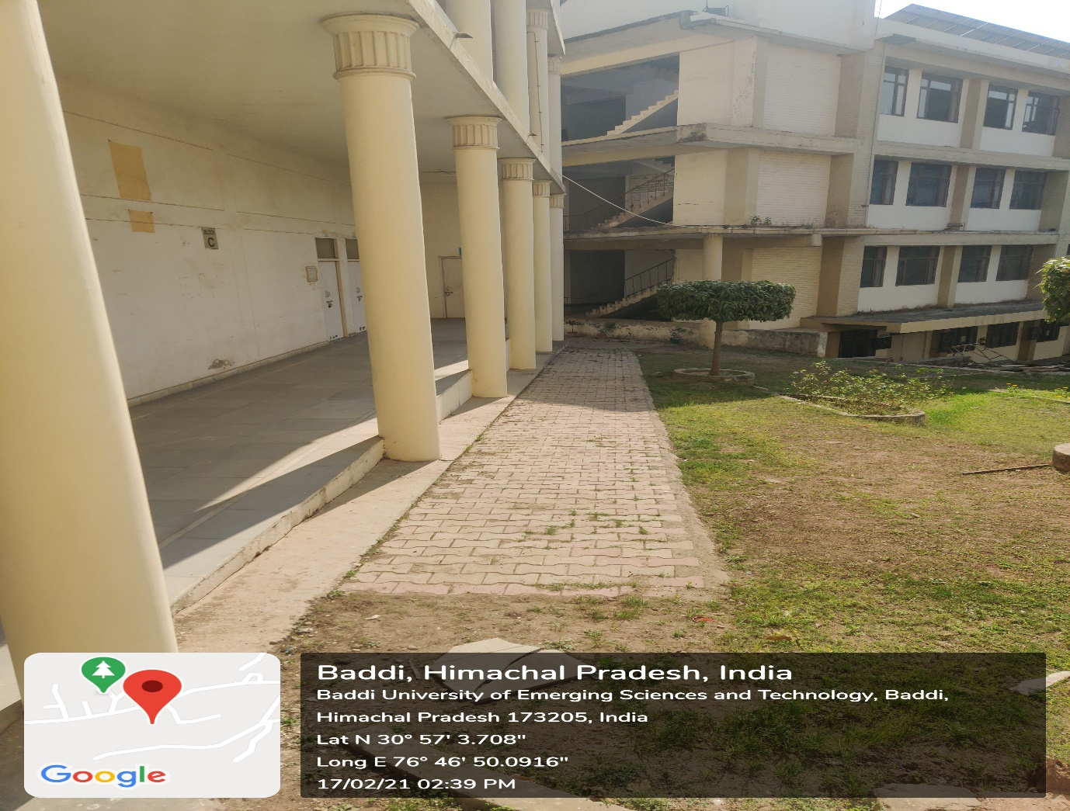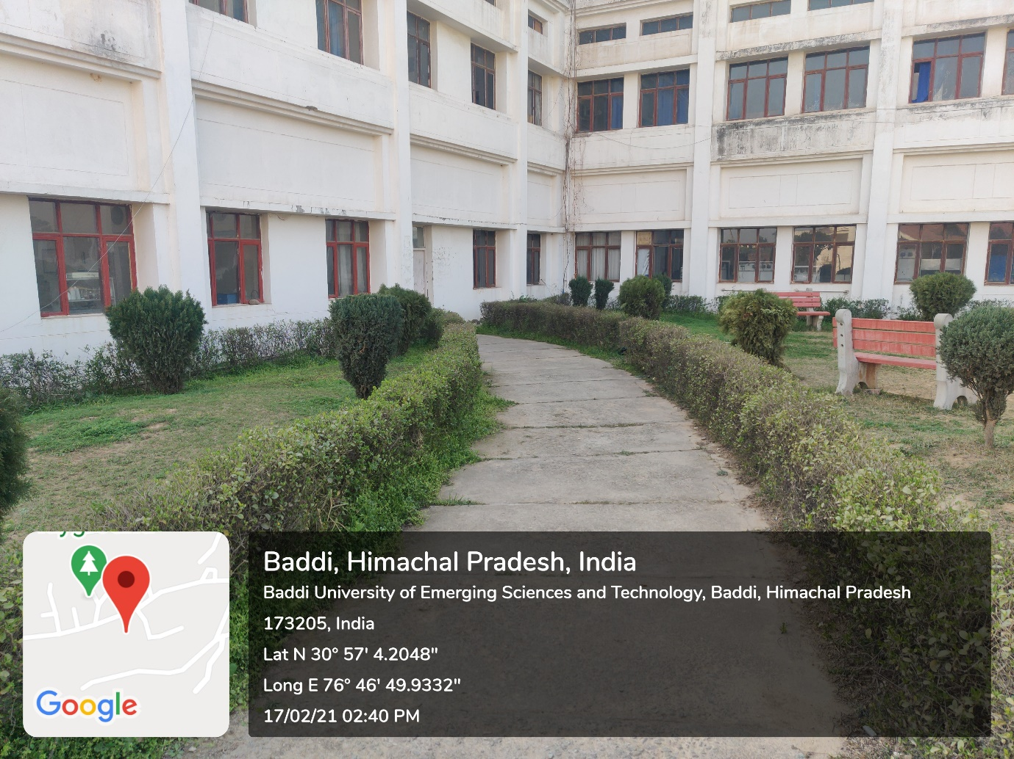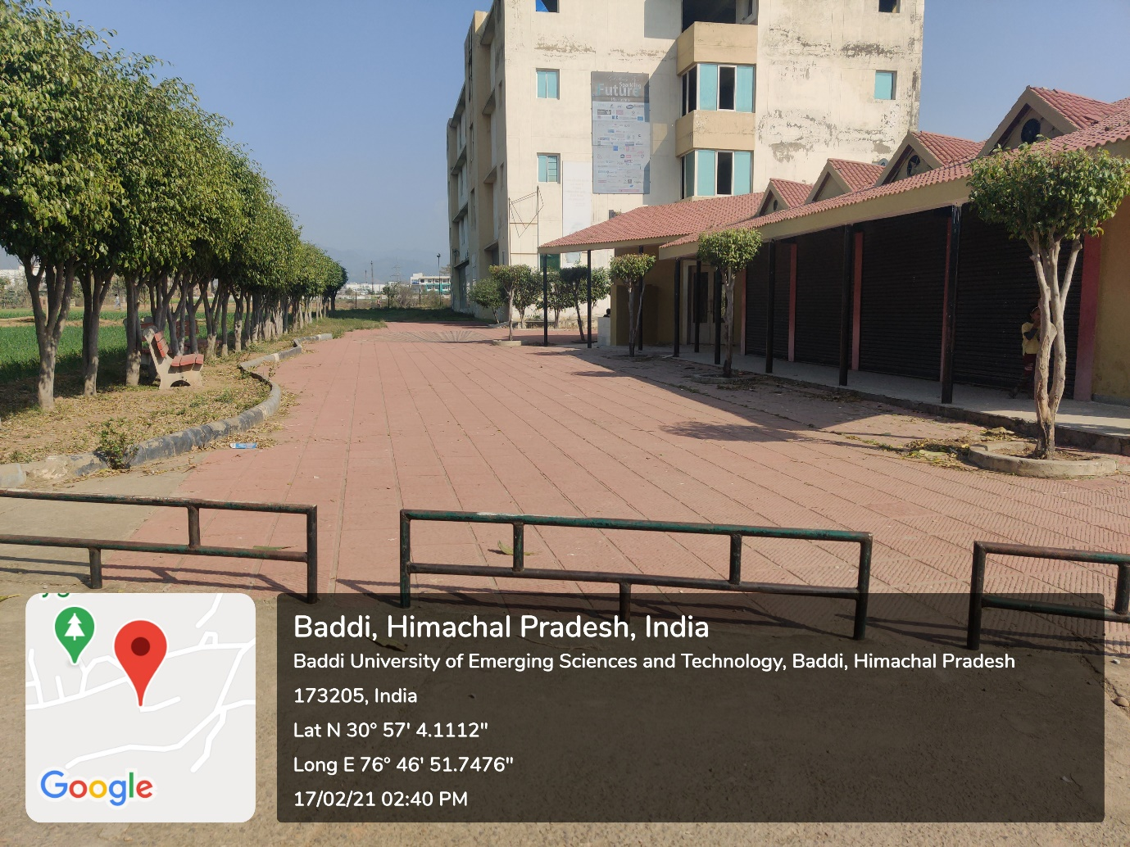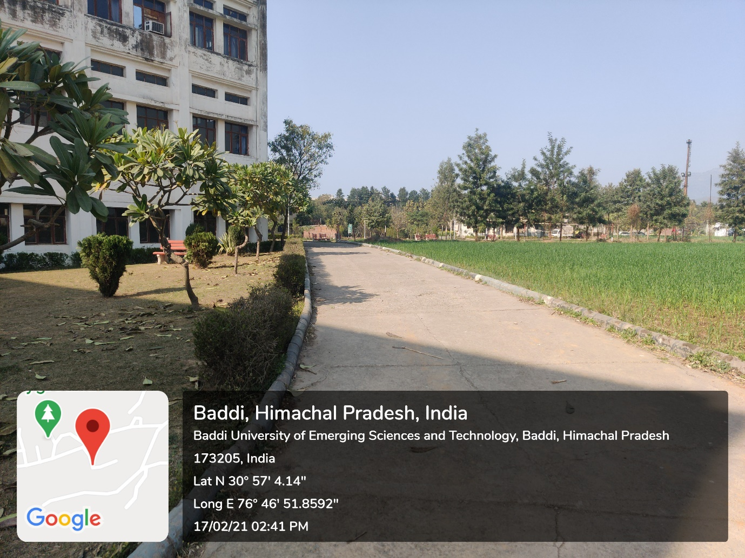

- Ban on use of Plastic
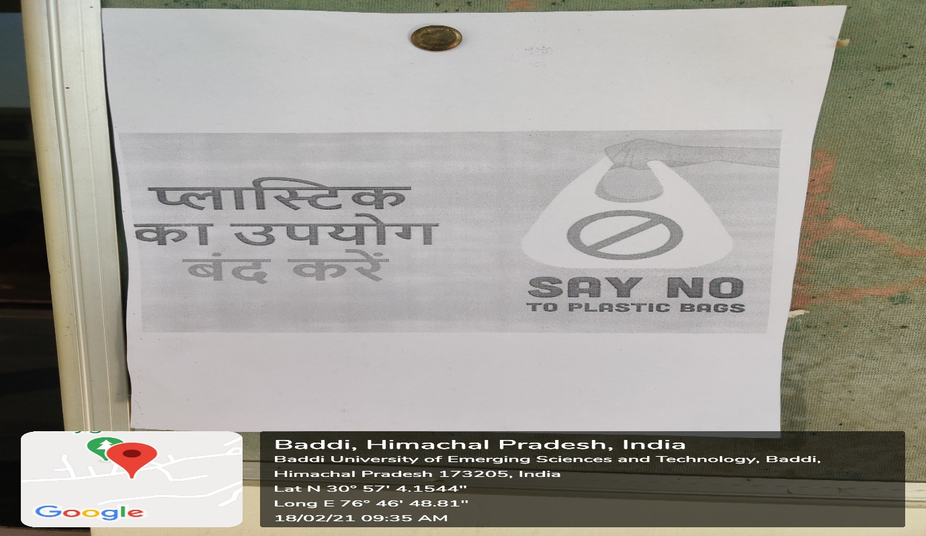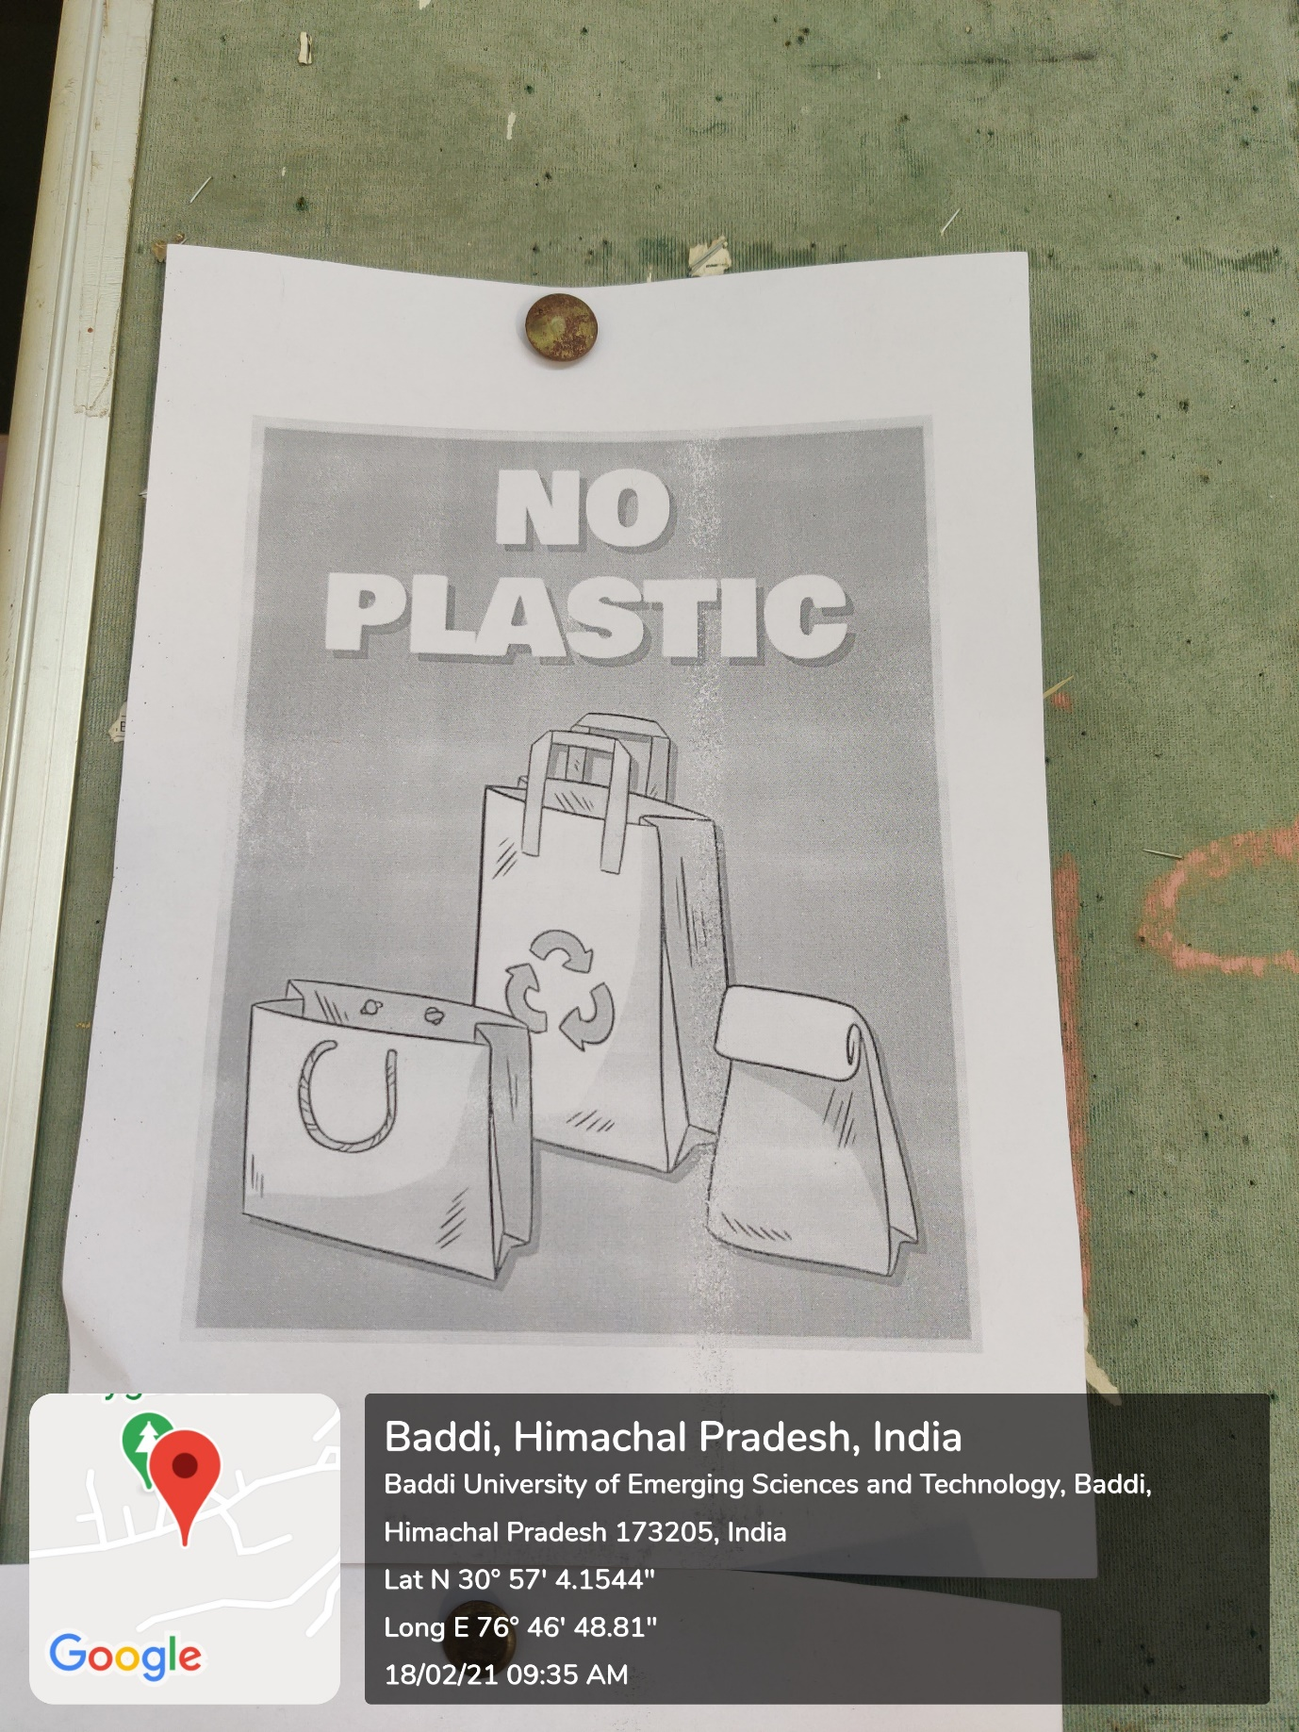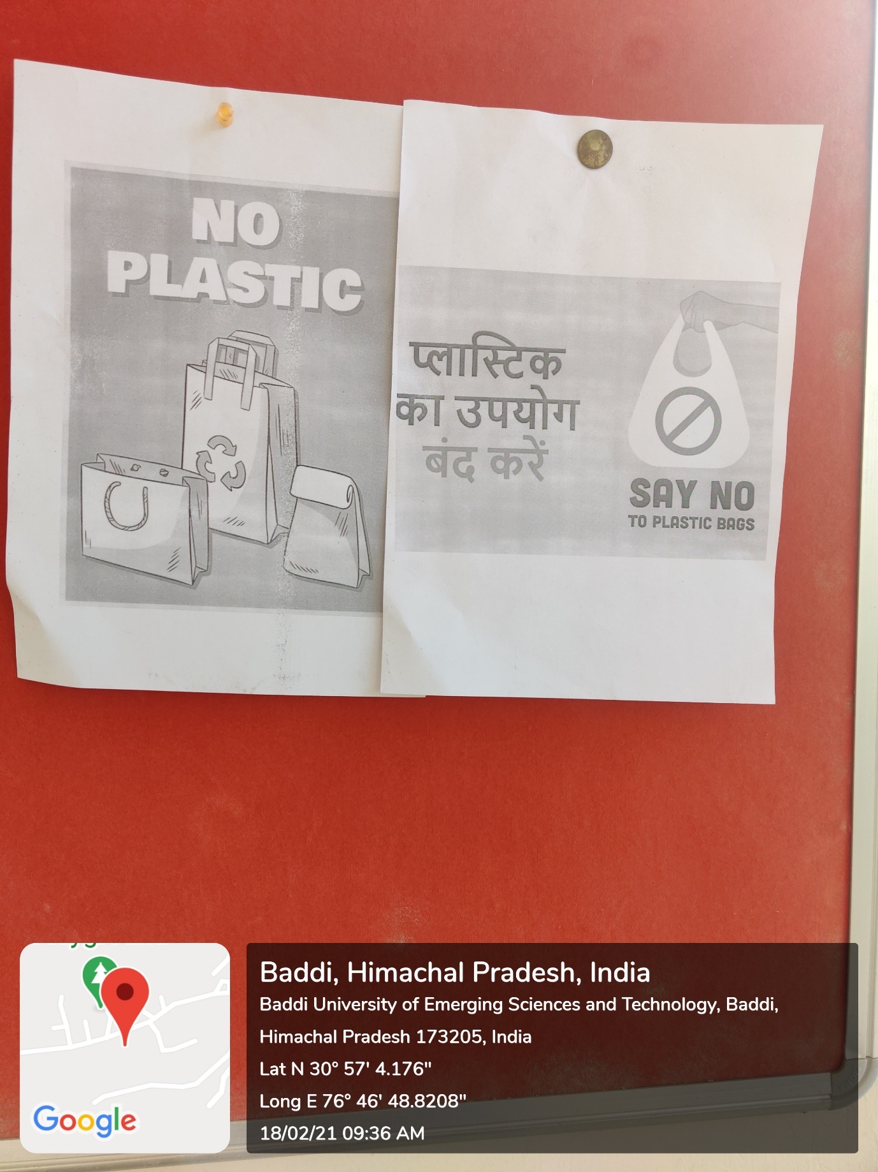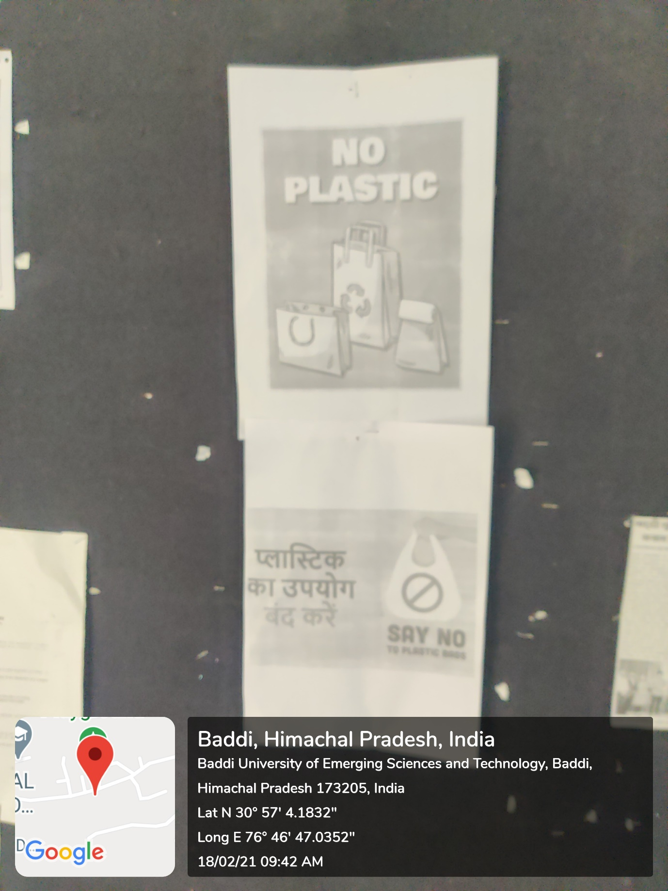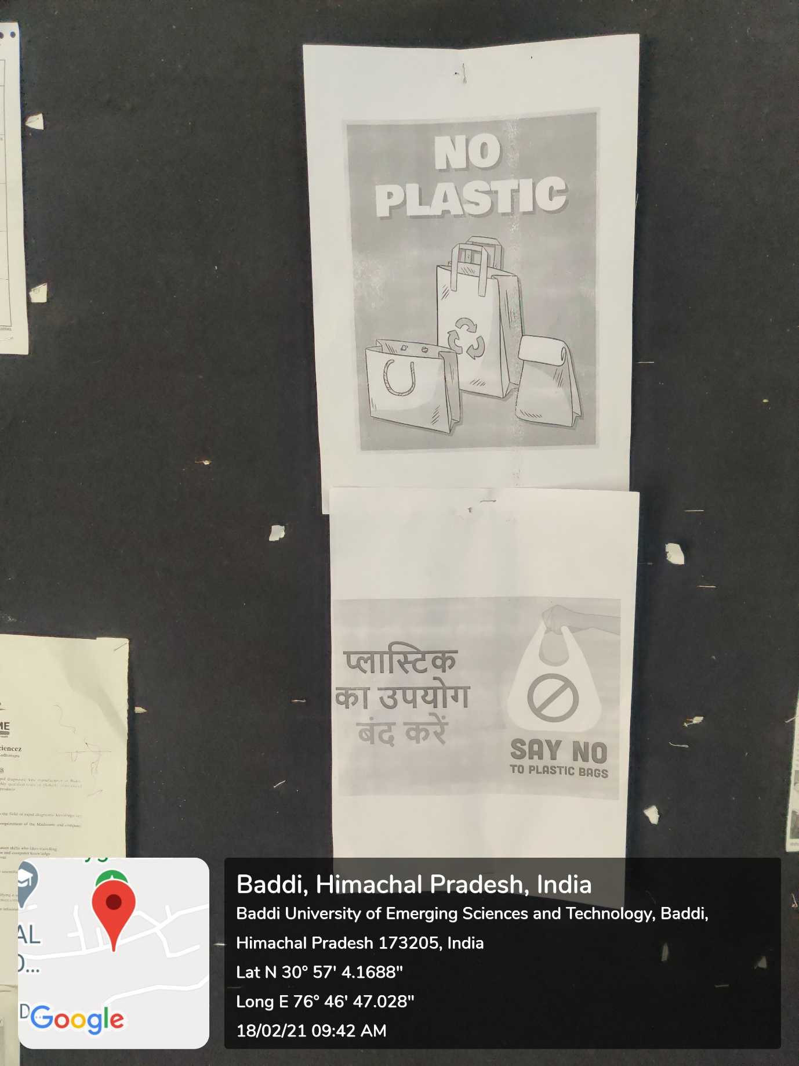

Landscaping with trees and plants

