7.1.4. Water conservation facilities available in the Institution:
1. Rain water harvesting
2. Borewell /Open well recharge
3. Construction of tanks and bunds
4. Waste water recycling
5. Maintenance of water bodies and distribution system in the campus

Options:
A. Any 4 or all the above
B. Any 3 of the above
C. Any 2 of the above
D. Any 1of the above
E. None of the above

Upload:
• Geotagged photographs /videos of the facilities
• Any other relevant information

7.1.4.1 Rain water harvesting

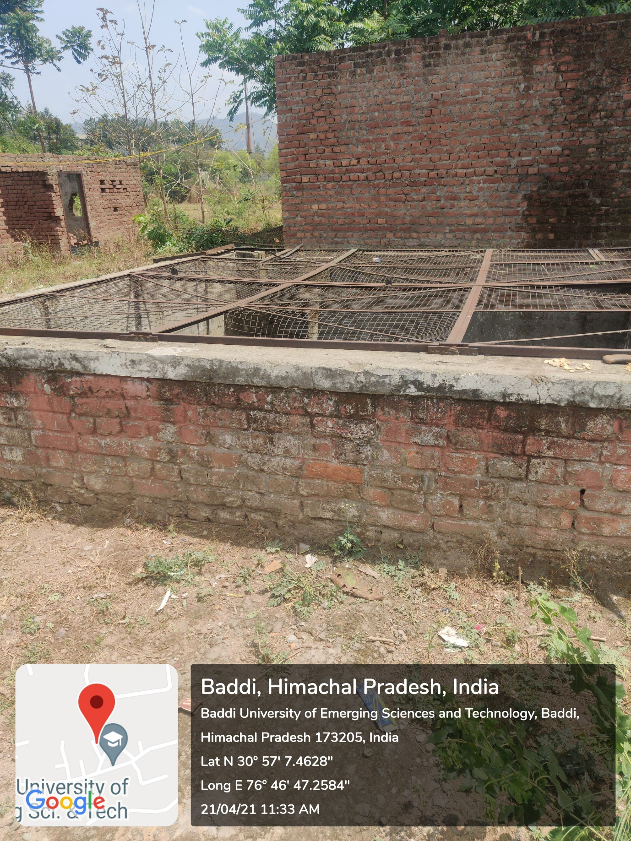

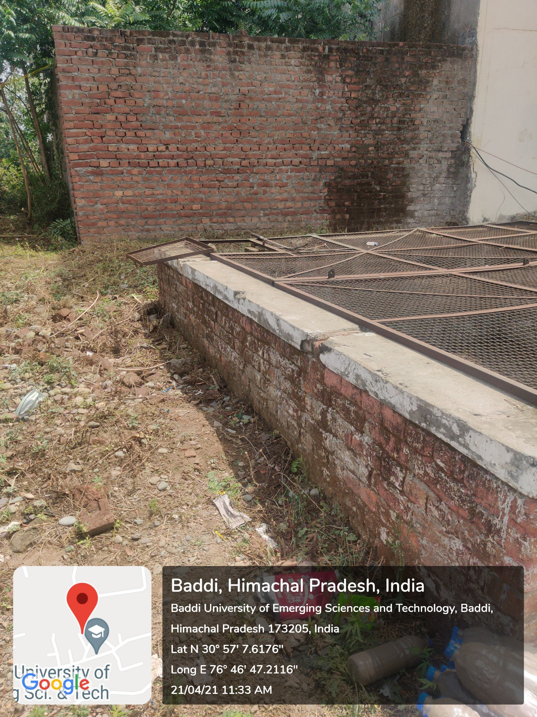

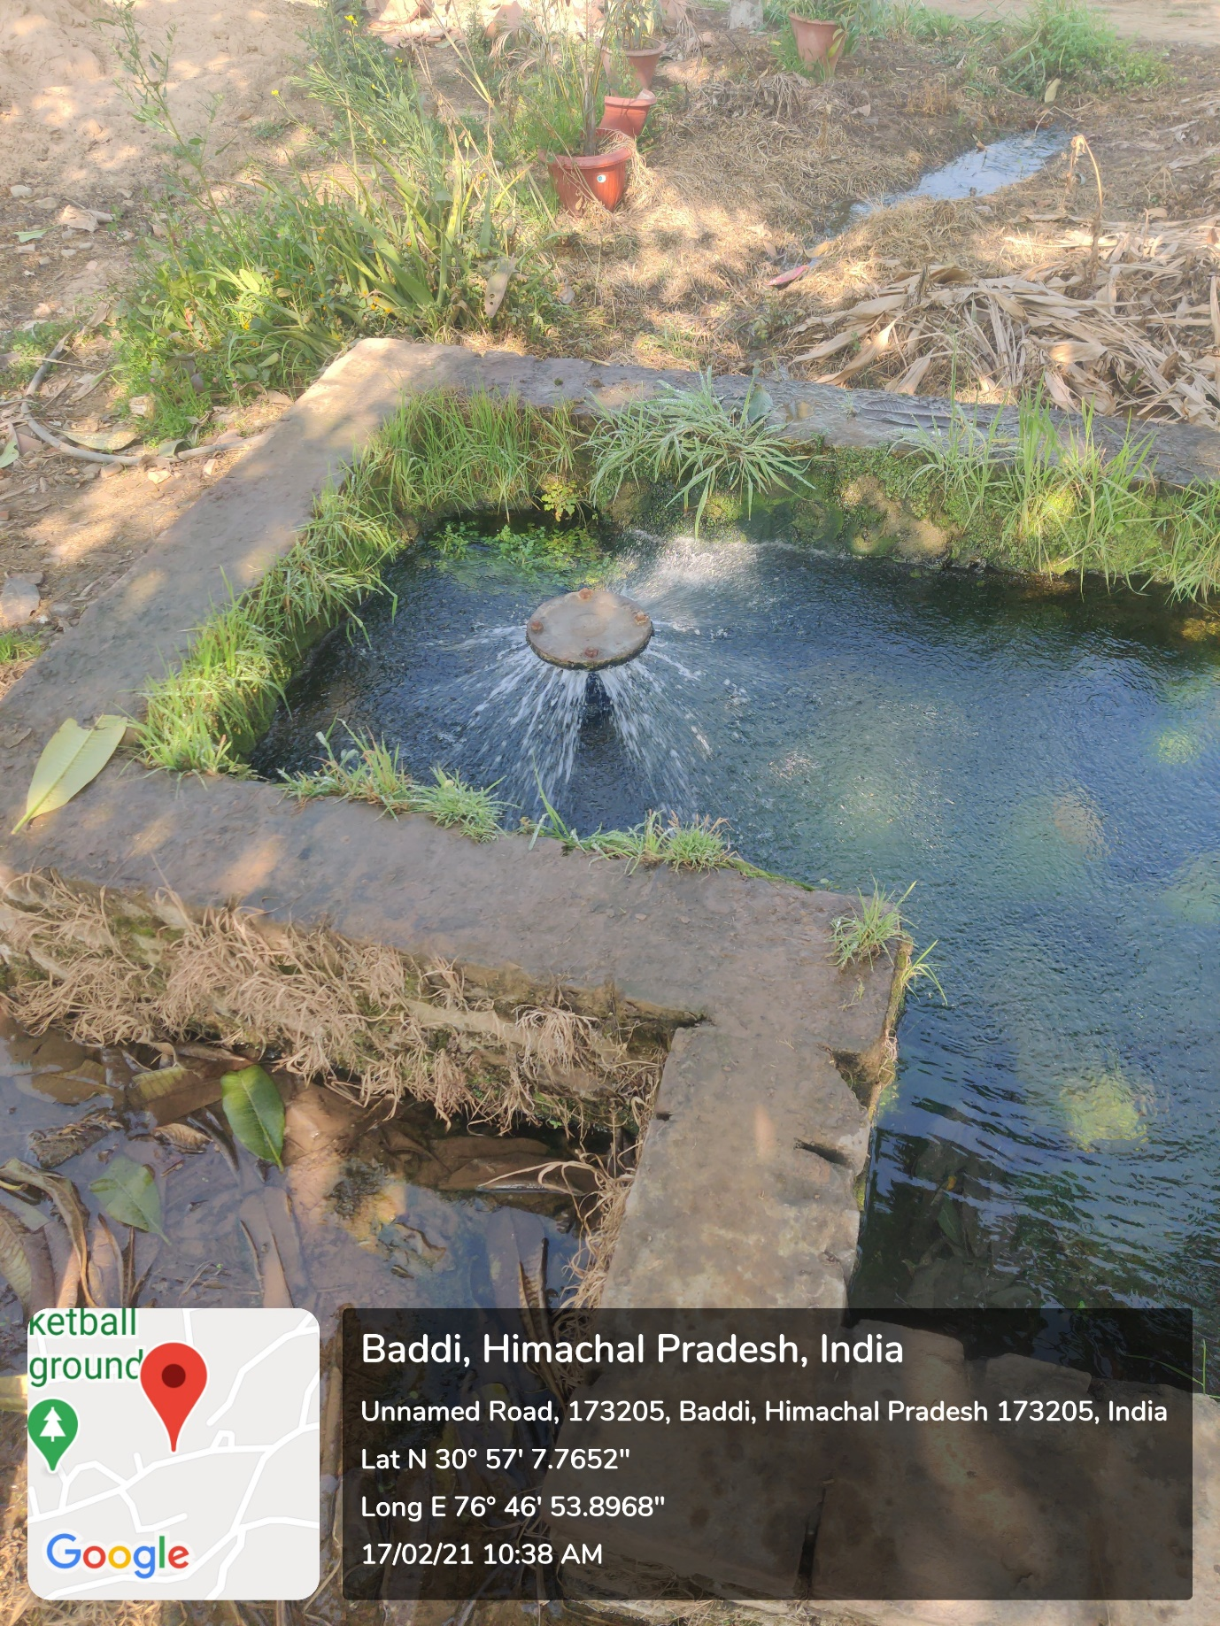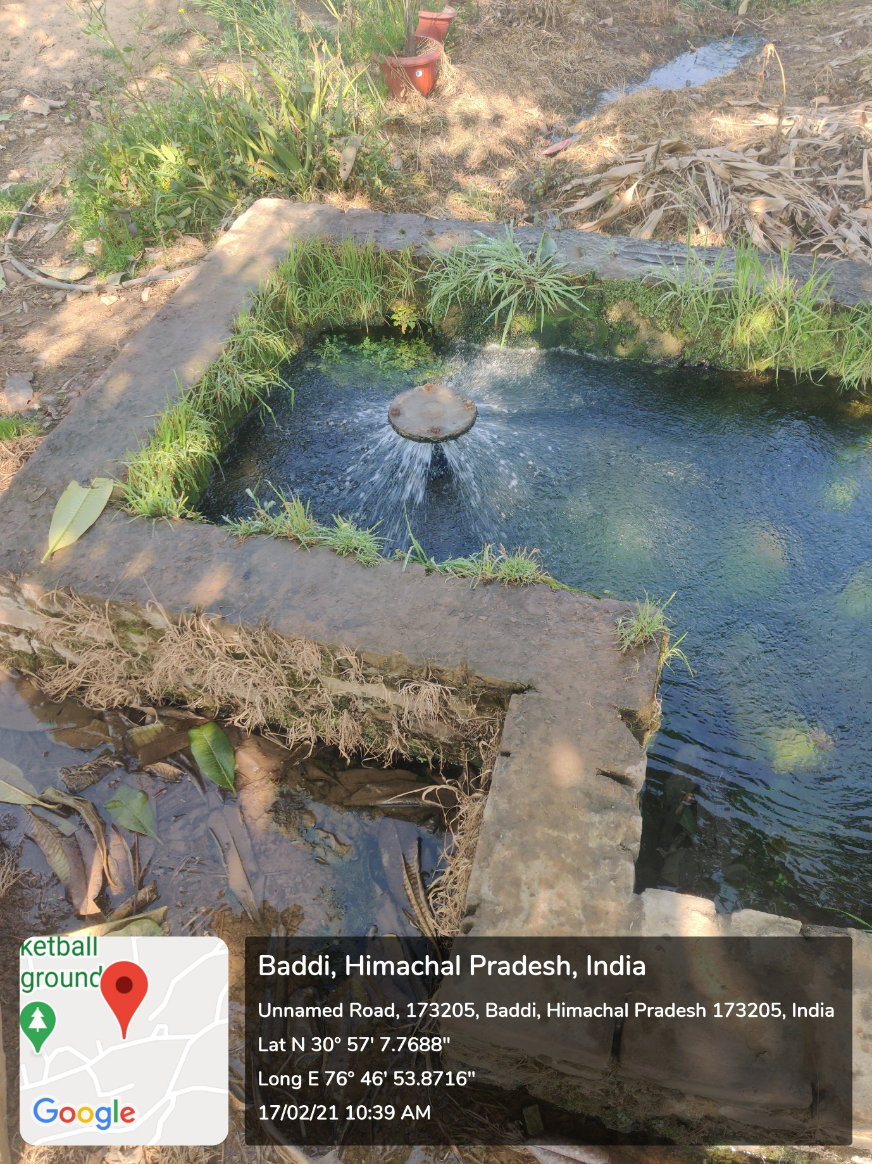

7.1.4.3 Construction of tanks and bunds

