7.1.2
The Institution has facilities for alternate sources of energy and energy conservation measures
1. Solar energy
2. Biogas plant
3. Wheeling to the Grid
4. Sensor-based energy conservation
5. Use of LED bulbs/ power efficient equipment

Options:
A. Any 4 or all of the above
B. Any 3 of the above
C. Any 2 of the above
D. Any 1of the above
E. None of the above

Upload:
• Geotagged Photographs
• Any other relevant information

- Solar Energy

Plant Capacity (DC): - 350.4 kwp
Plant Capacity (AC): - 357 kwp

S.No. | Year | Total Energy Generated(kWh)
1 | 2018 (Nov-Dec) | 91810.51
2 | 2019 | 4,12,055.32
3 | 2020 | 4,54,099.44
4 | 2021 | 444127.00
5 | 2022 | 498313.00
6 | 2023 | 435841.00

Actual Plant Picture

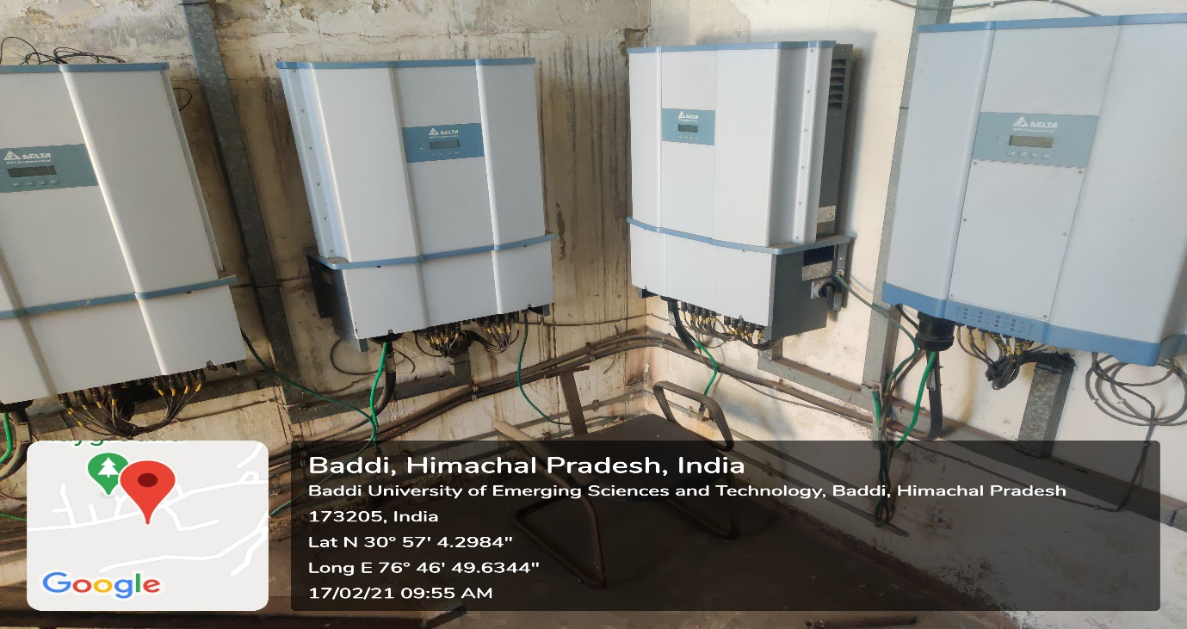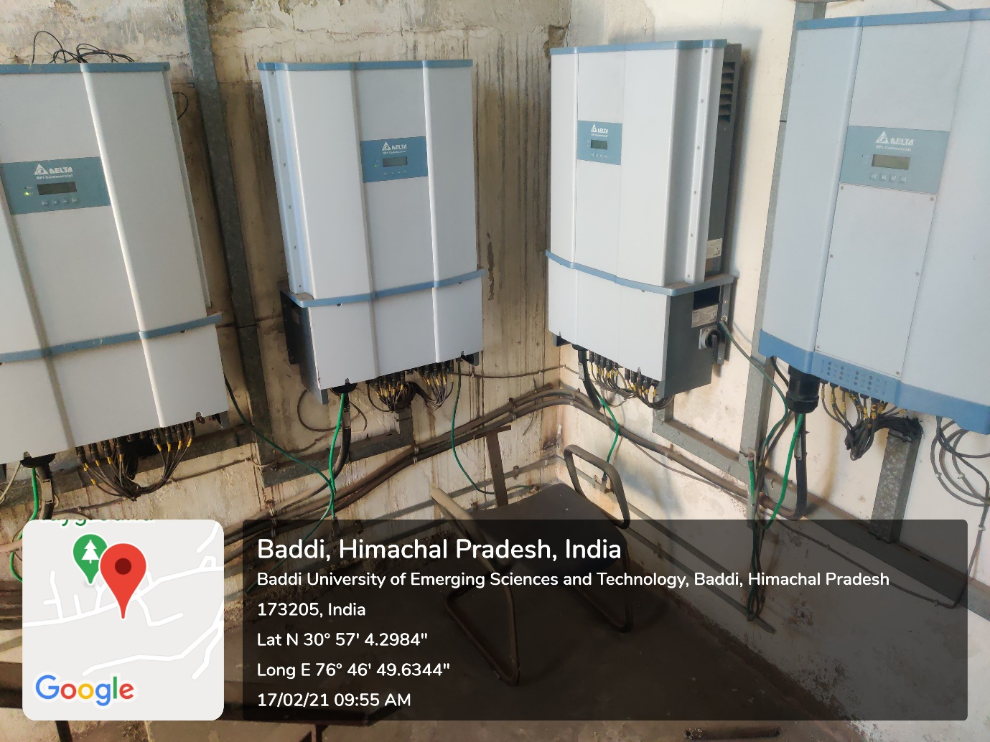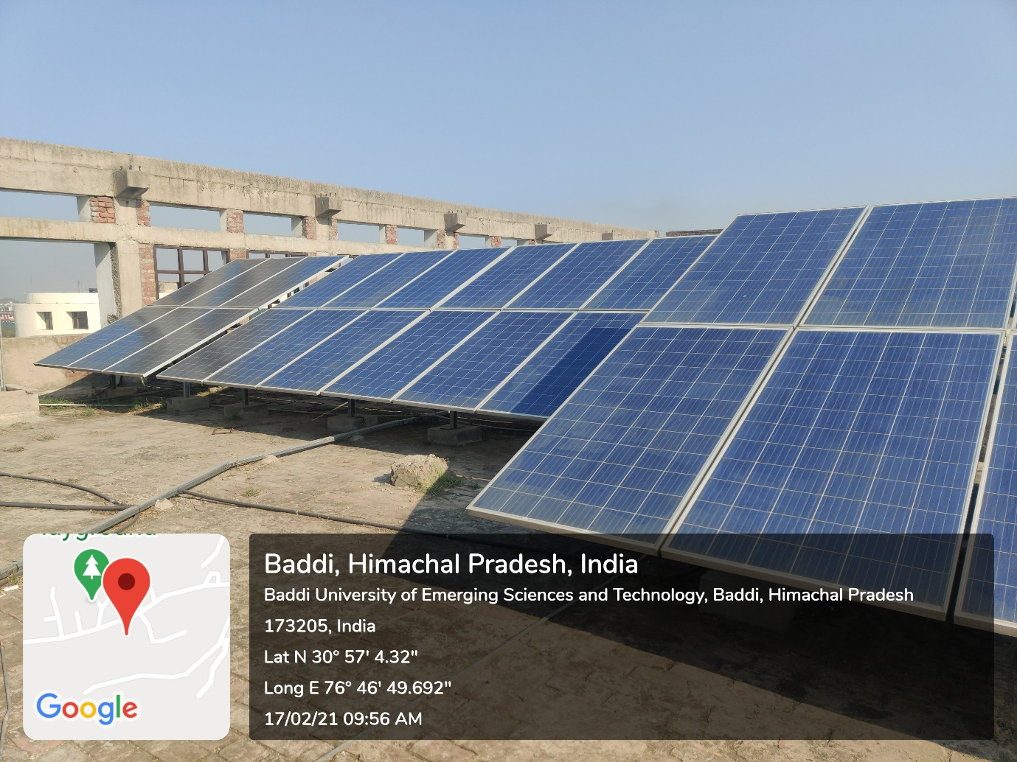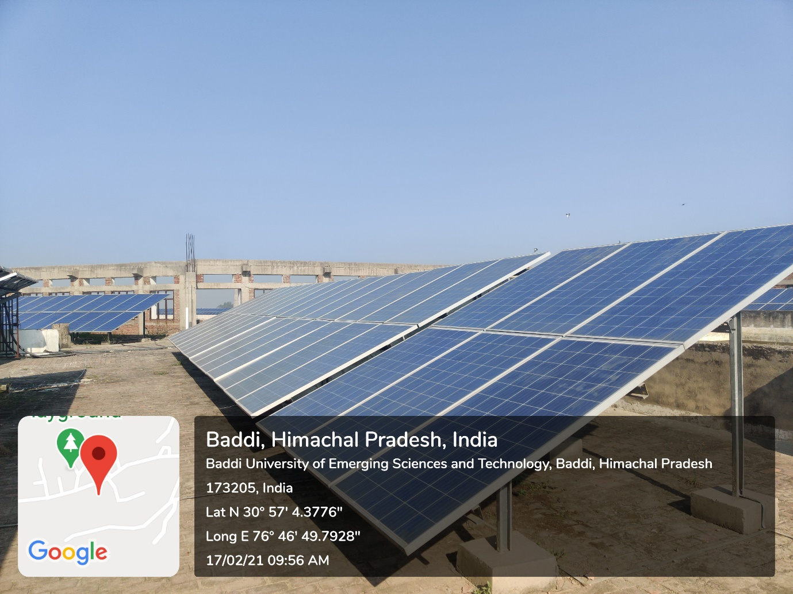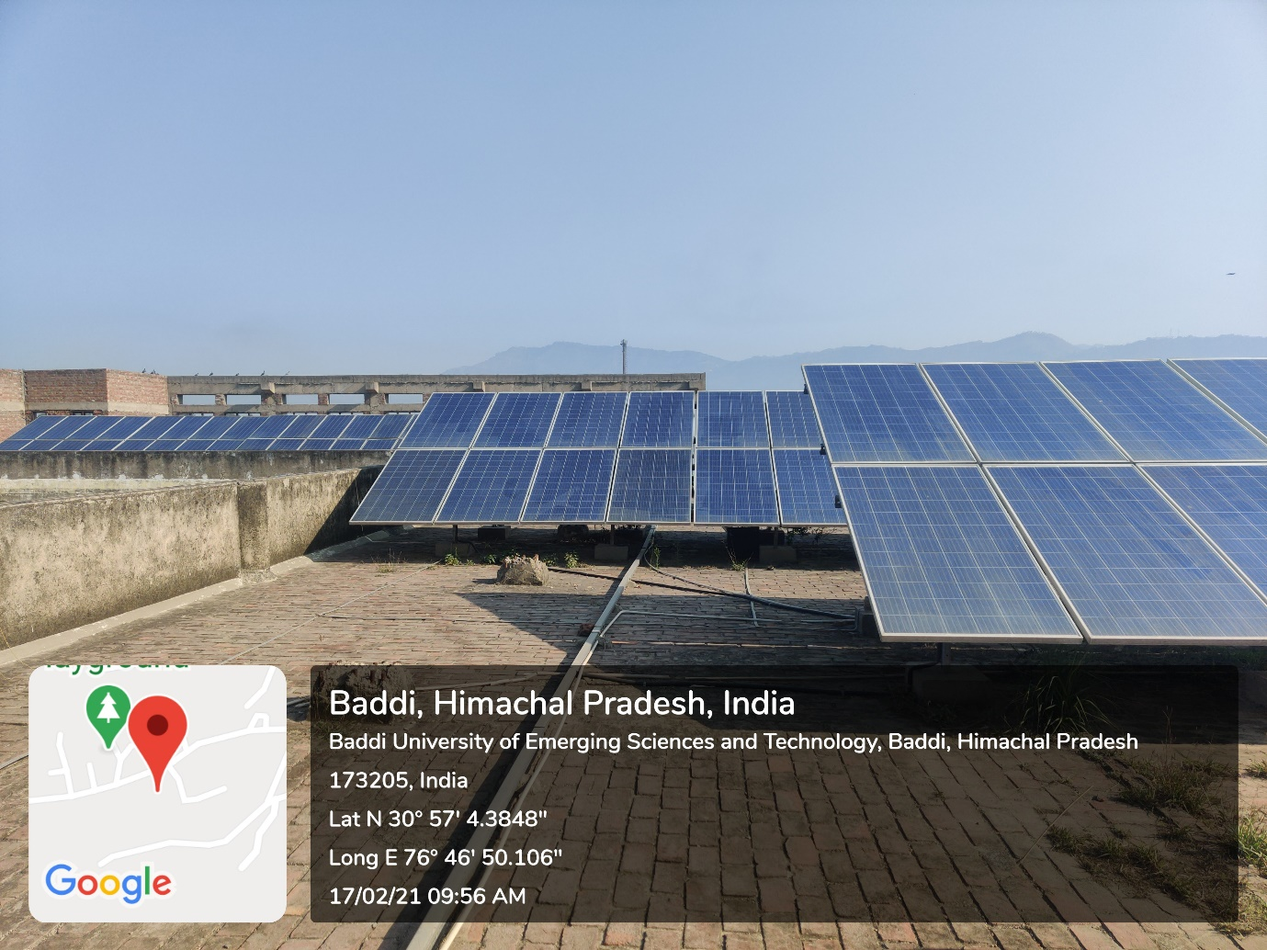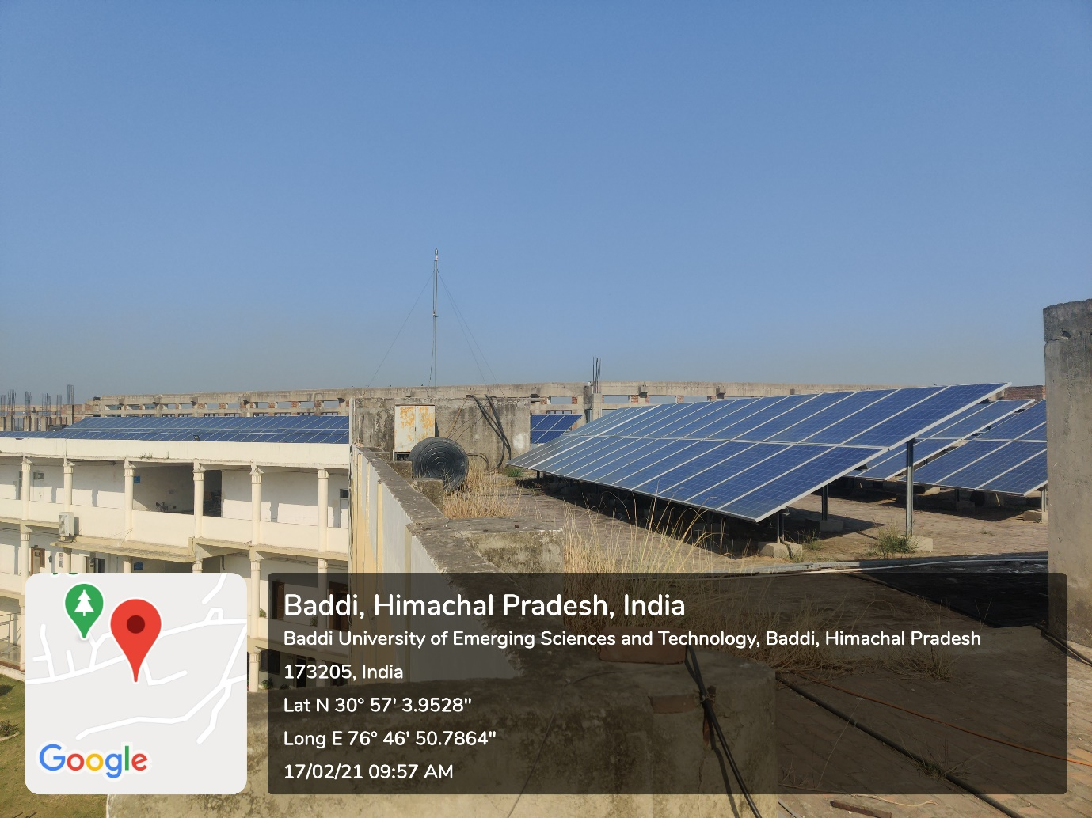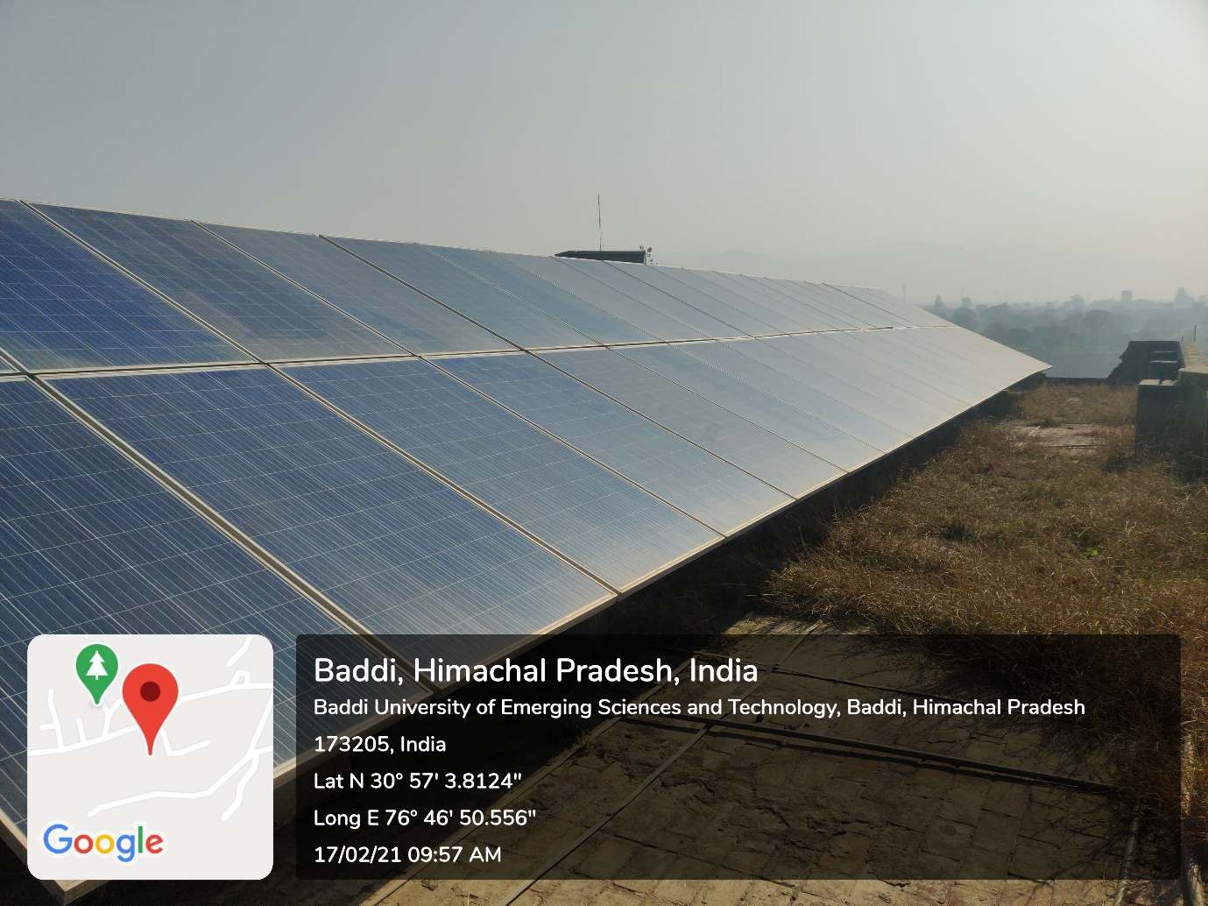.

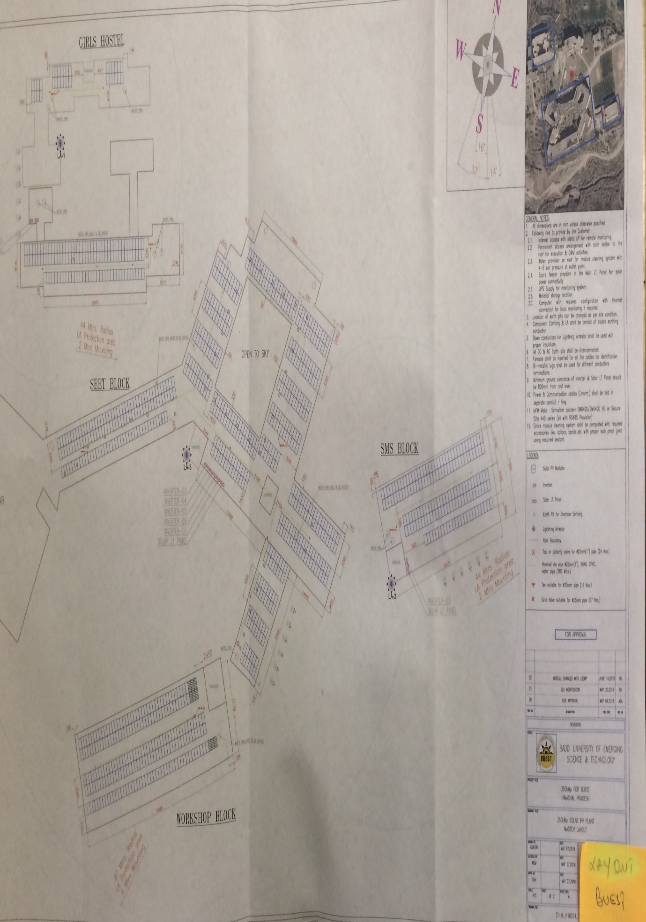

- Biogas Plant

N/A

- Wheeling to grid

It refers to the process of transmission of electricity through the transmission lines.
The University campus have a on grid solar power plant and the extra energy units generated by solar power plant exported to grid through net meter.

Actual images of Wheeling to grid.

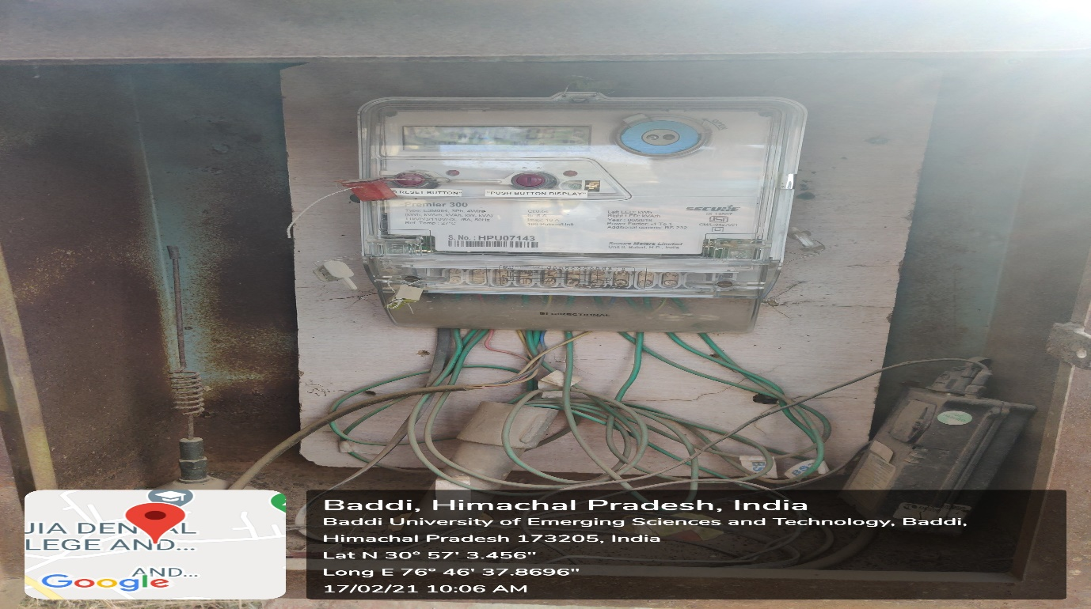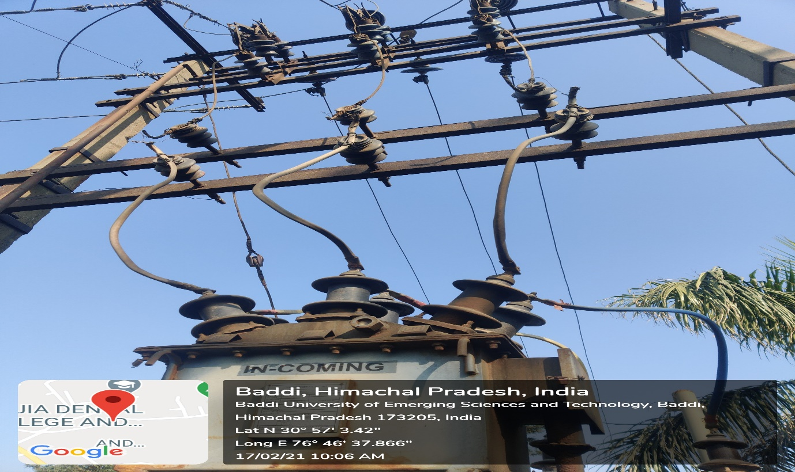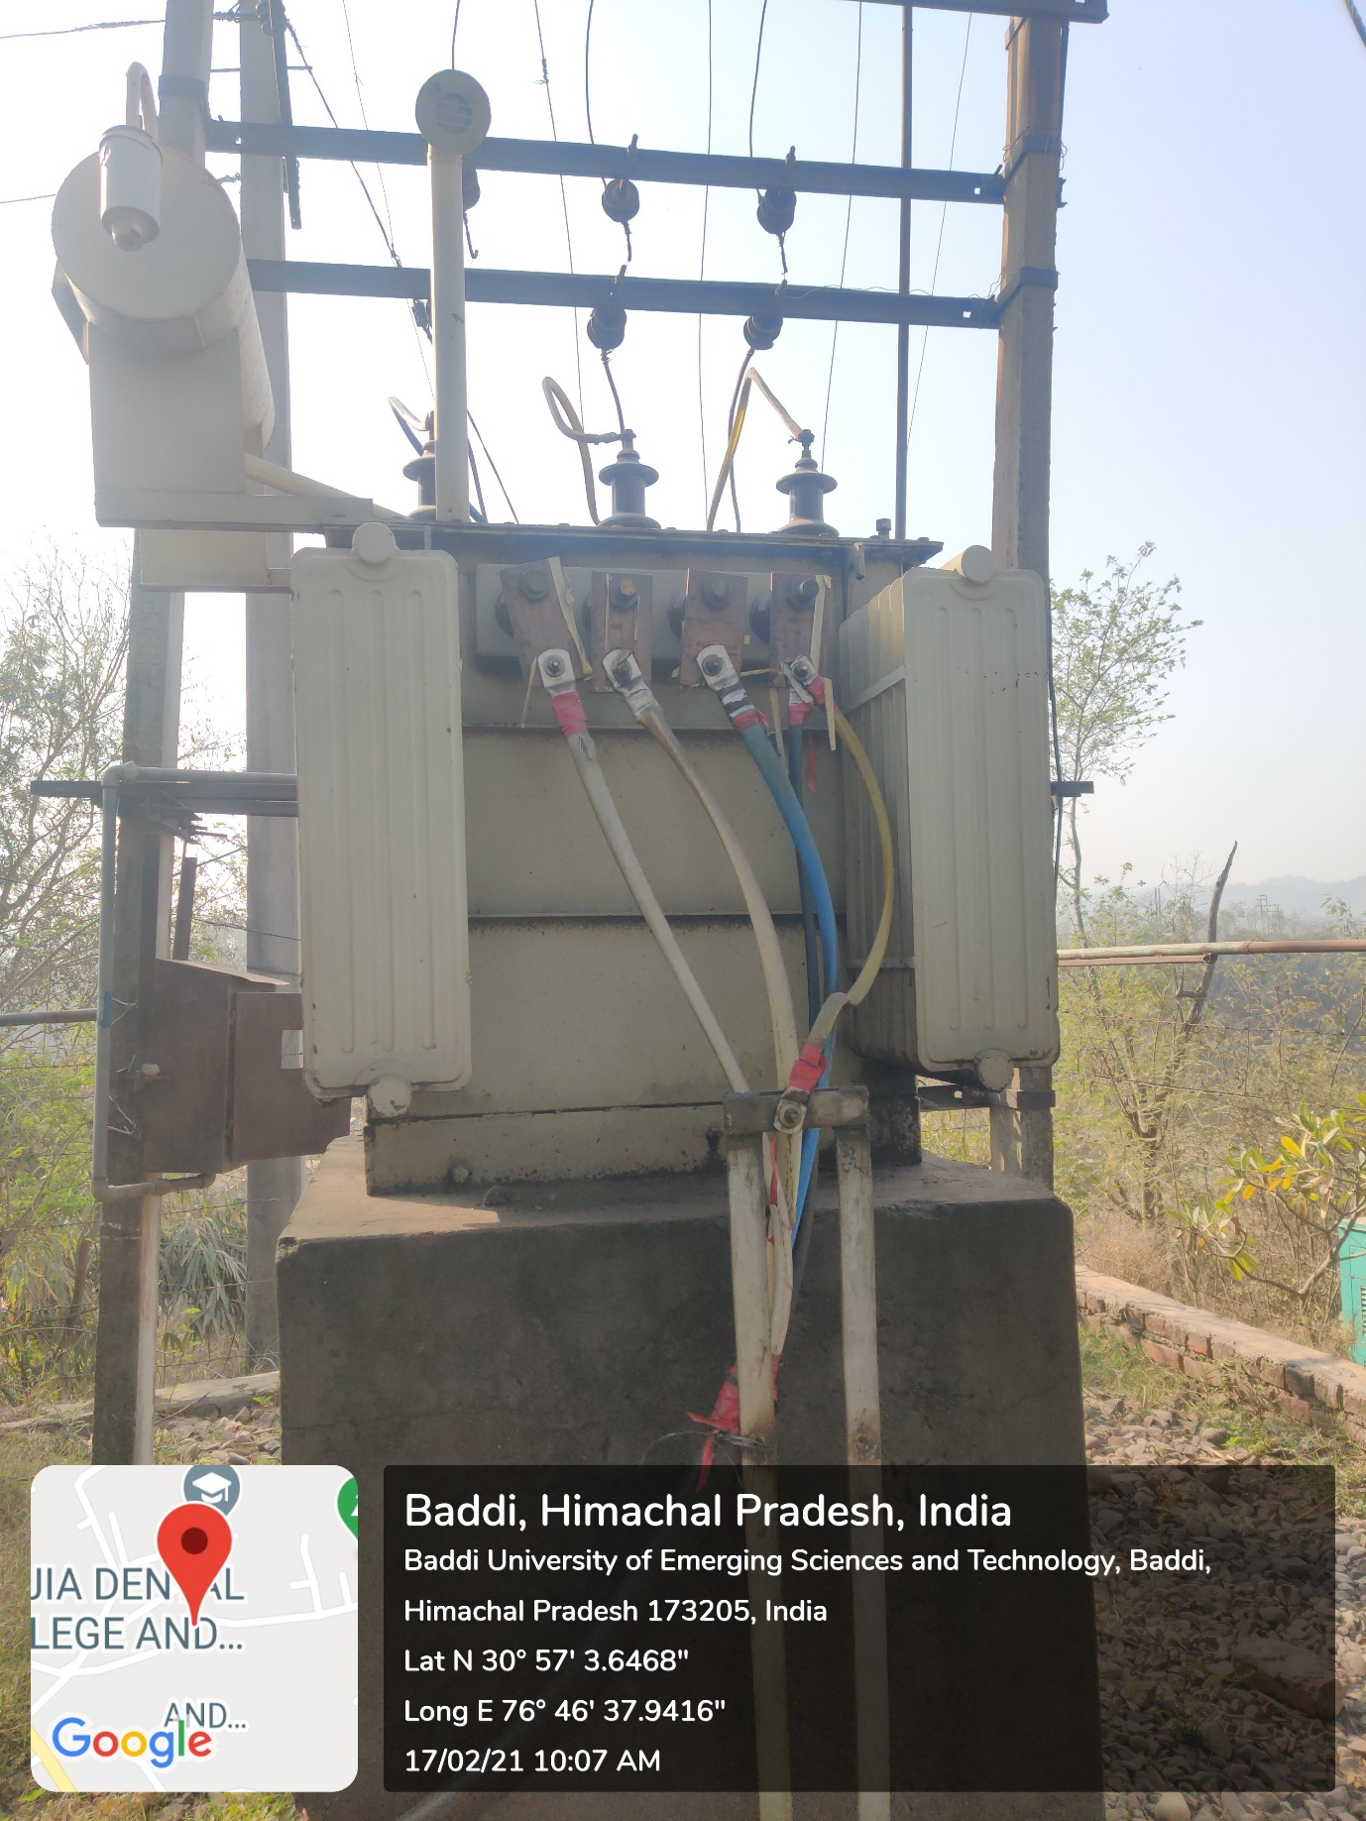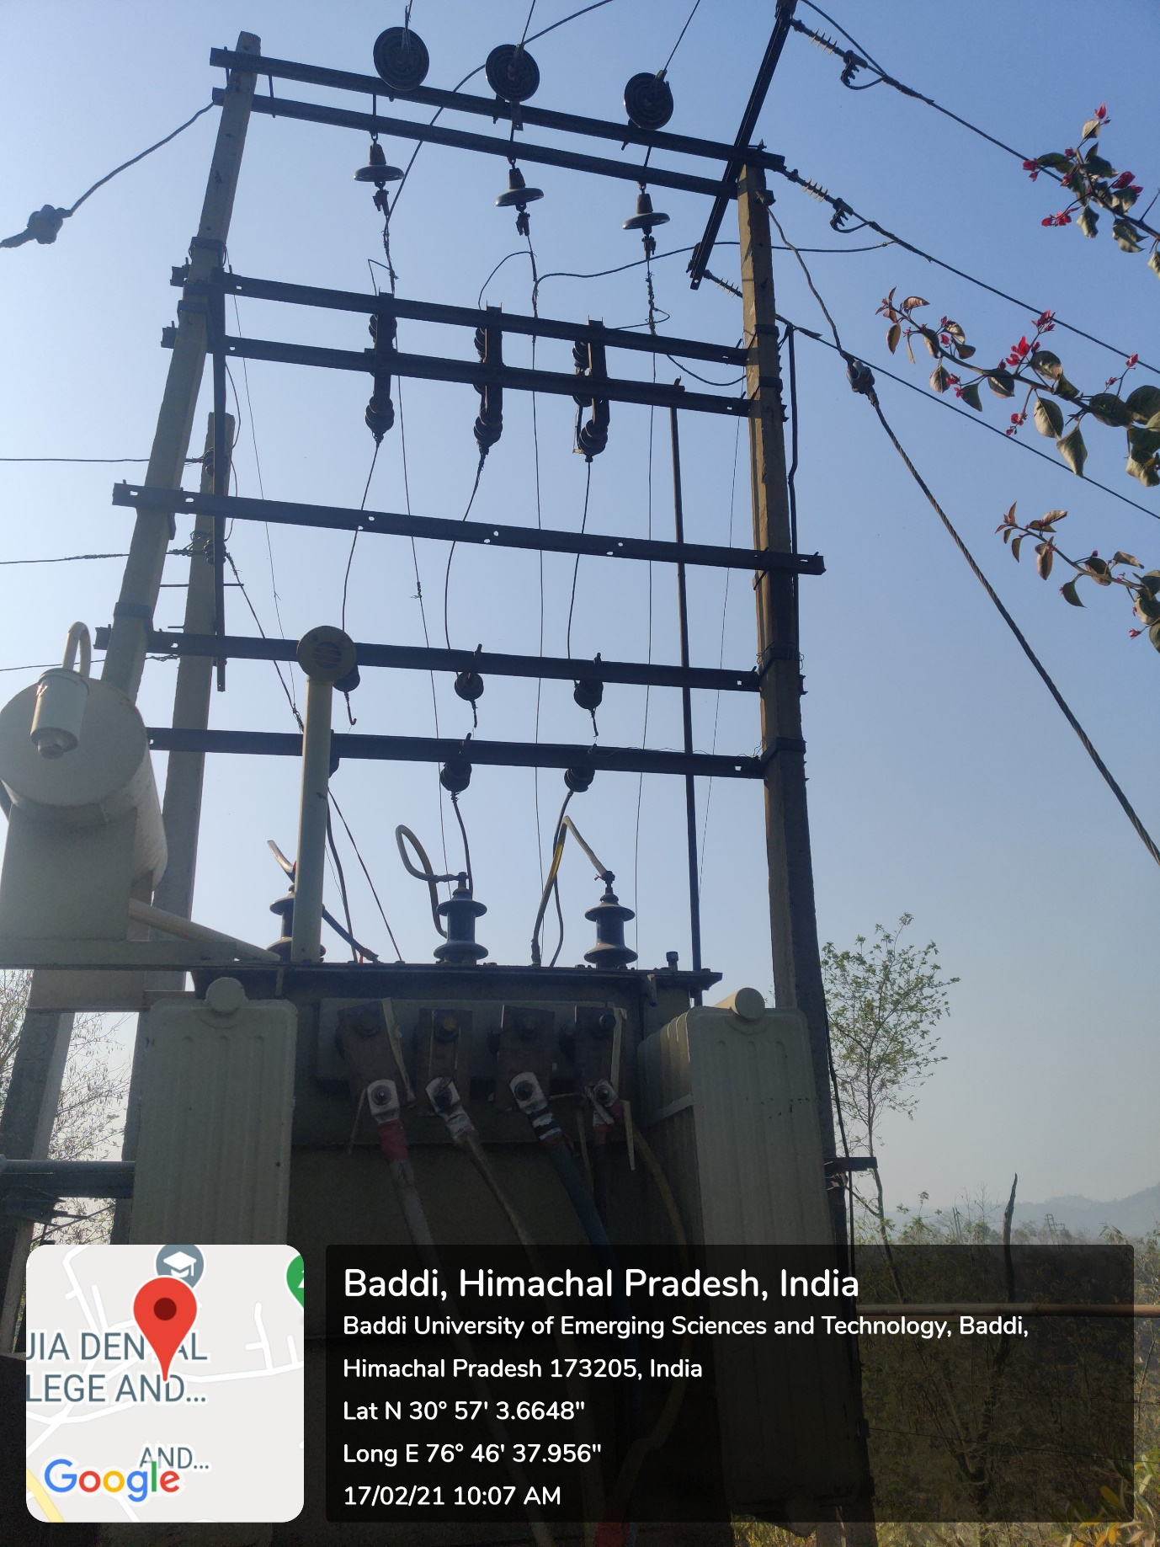

Use of LED bulbs/ power efficient equipment

