Institution has initiated Gender audit and measure for the promotion of gender equity.

Baddi university of Emerging Sciences and Technology has a strong ethical work culture that is based on inclusivity. It observes highest ethical standards in all its activities. Equal opportunities are provided to all individuals irrespective of gender, race, caste, color, creed, language, religion, political or other opinion, national or social origin, property, birth or other status. Its unique work culture, healthy traditions and ethos have led to enrolment of women students and women staff. Safety, security and well-being, along with gender equity and friendly working atmosphere are the issues of prime concern to Baddi University of Emerging Sciences and Technology. Gender sensitivity is an inherent value in the cultural ethos of the institute and its neighbouring community, as is evident by the following facilities –

(a)Safety and Security

• Well-trained and vigilant women security guards stationed across the campus.
• Security checkpoints at all campus entries and exits.
• Rotational duty by all faculty members for discipline and security.
• The Proctorial Committee includes male and female proctors at institute as well as faculty level.
• Night Patrols by local community including students and teachers.
• Strict implementation of Anti-Ragging and Anti-Smoking Campus.
• Awareness campaigns on women safety and gender sensitivity through street plays (Nukkad Natak), rallies and camps by NSS student volunteers.
• Separate hostels for men and women with dedicated wardens.
• The Institute is the preferred destination of parents for education of their female wards as evidenced by the Stakeholder Feedback.
• Eco-friendly crèche for wards of institute staff with dedicated staff and faculty supervisors.
- Emergency contact numbers are displayed in prominent places in the campus

(b) Counselling
- Faculty counsel the students during mentoring regarding academic performance, career plans and personal issues.
- Head of the department monitors the students and counsel the students regarding depression or misbehaviour.
• Formal and informal avenues for counselling male and female students and staff for academic and other issues/problems.
• Class and Proctorial Committees are available for counselling of both males and female’s students.
• Grievance Redressal Committees for staff and students.
• Campaigns against female feticide.
• Faculty Placement Cells and Alumni Placement Assistance Cell.
• Others – Entrance Exam Counselling, Matrimonial Counselling, Orientation Programmes for Teachers and Students.
• Medical Counselling, Moral Counselling, Career Counselling, Village Counselling, Vocation Counselling.

(C) Common Rooms.
- Health Centre is available in the campus with qualified physician with separate treatment rooms for girls and boys. Free medicines are provided on requirement.
- Separate space and courts are provided for sports and games of girls and they are always encouraged.
(E). Any other relevant information.
Baddi University of Emerging Sciences and Technology offer ‘BETIYON KI BARI’ (BKB) is BUEST's own unique initiative to promote professional education among girl students of Himachal Pradesh, to enable them to carve out a distinct niche themselves to saver the fruits of growths and industrialization. BKB is an exclusive scholarship scheme for girl students who intend to excel on professional front.
Scholarships - Best Engineering College in Himachal Pradesh | Best University in Himachal Pradesh | Baddi University

Safety and Security.
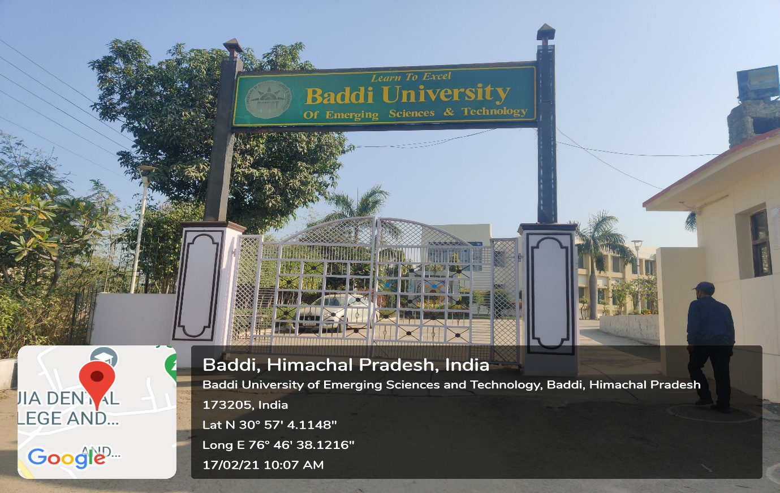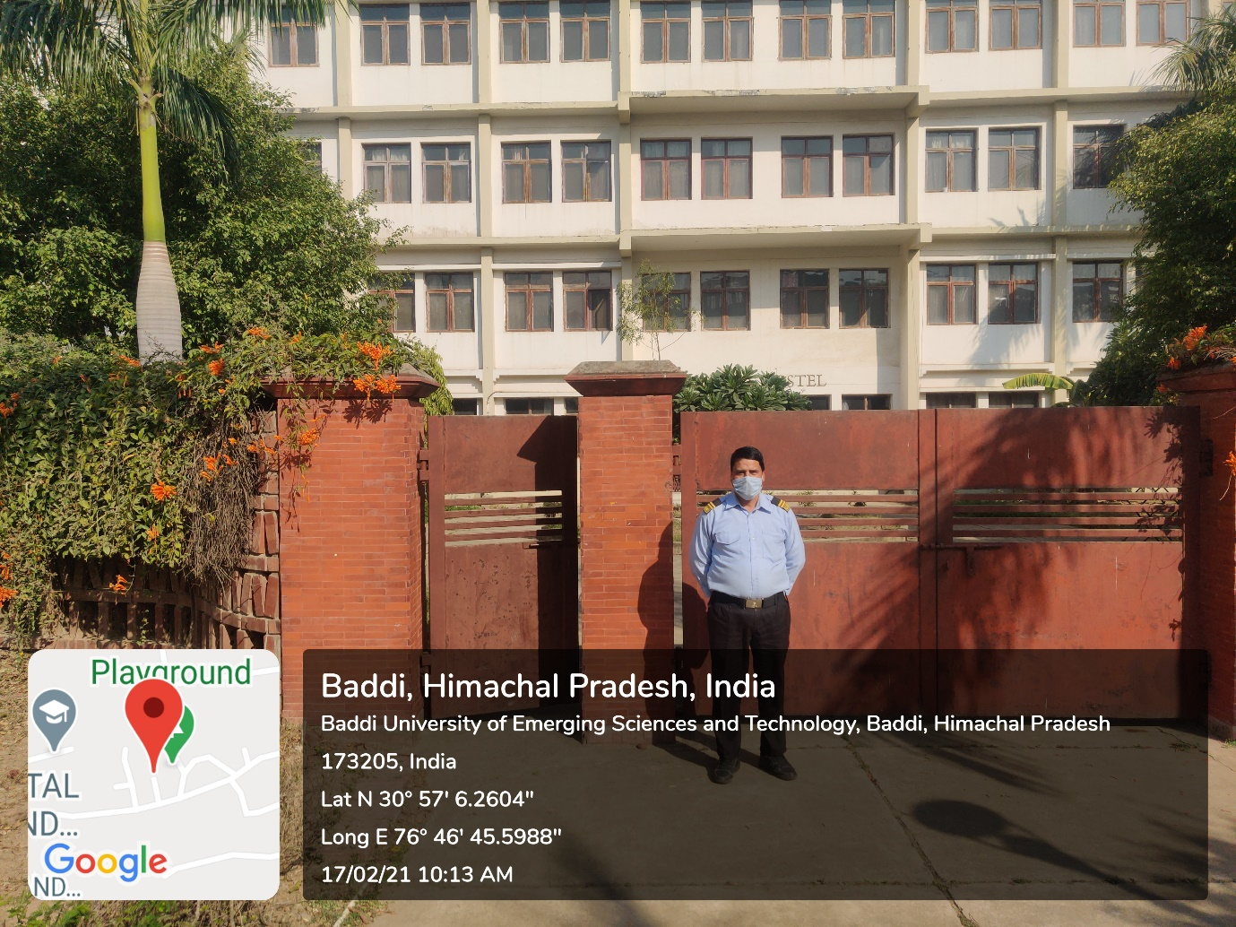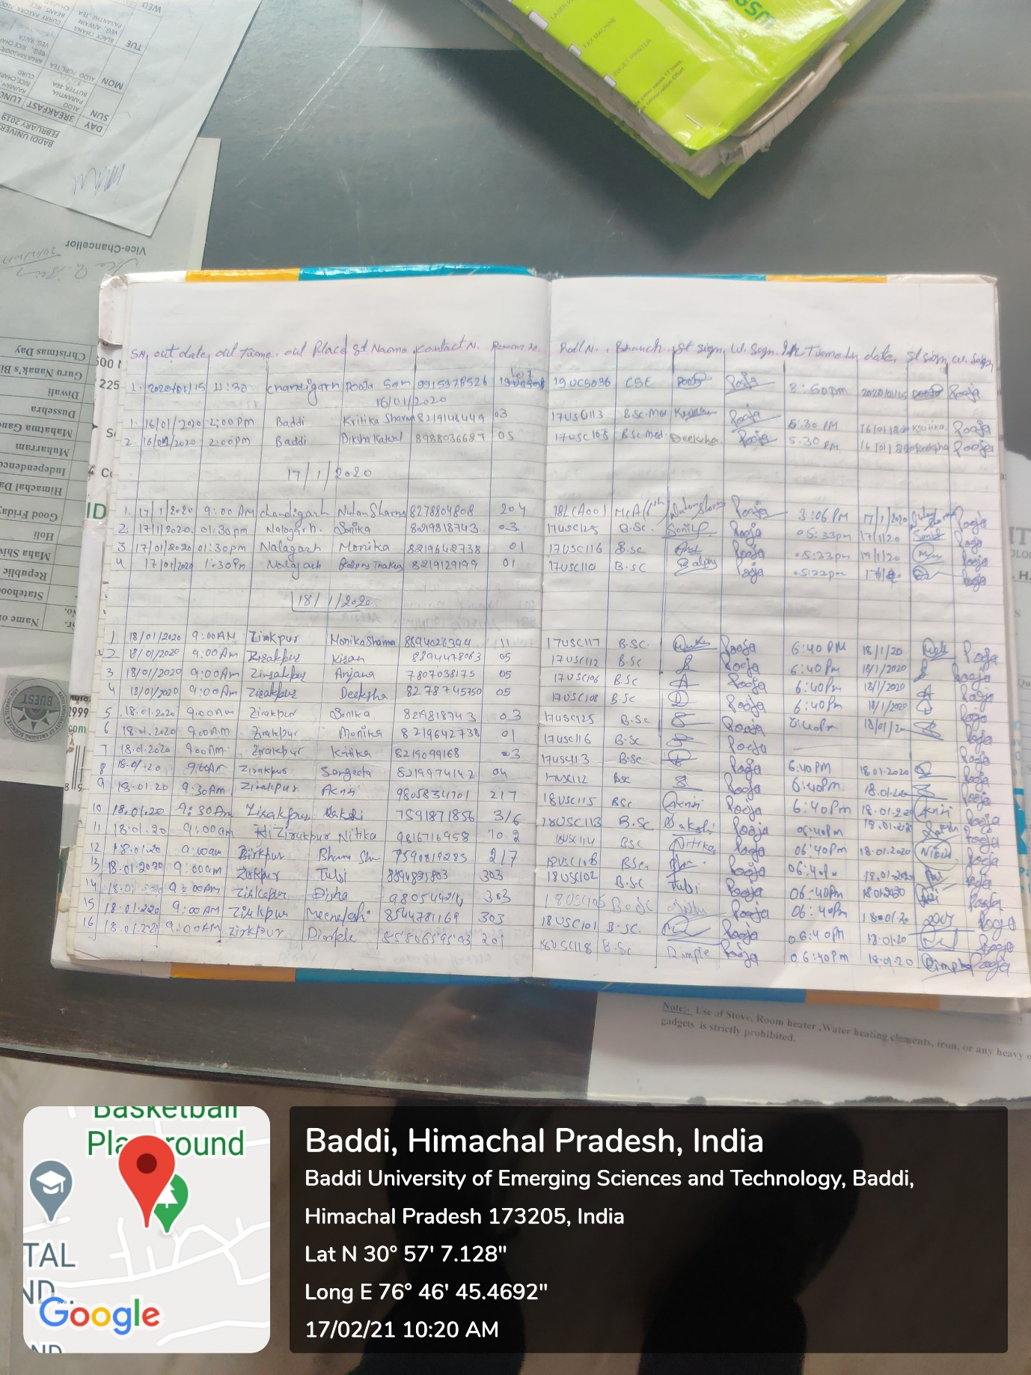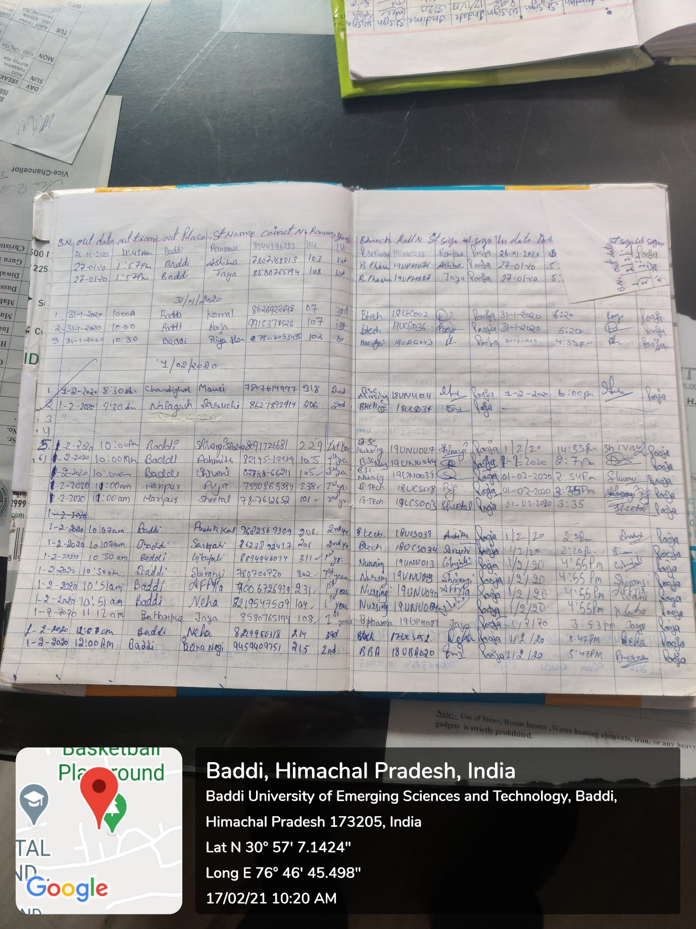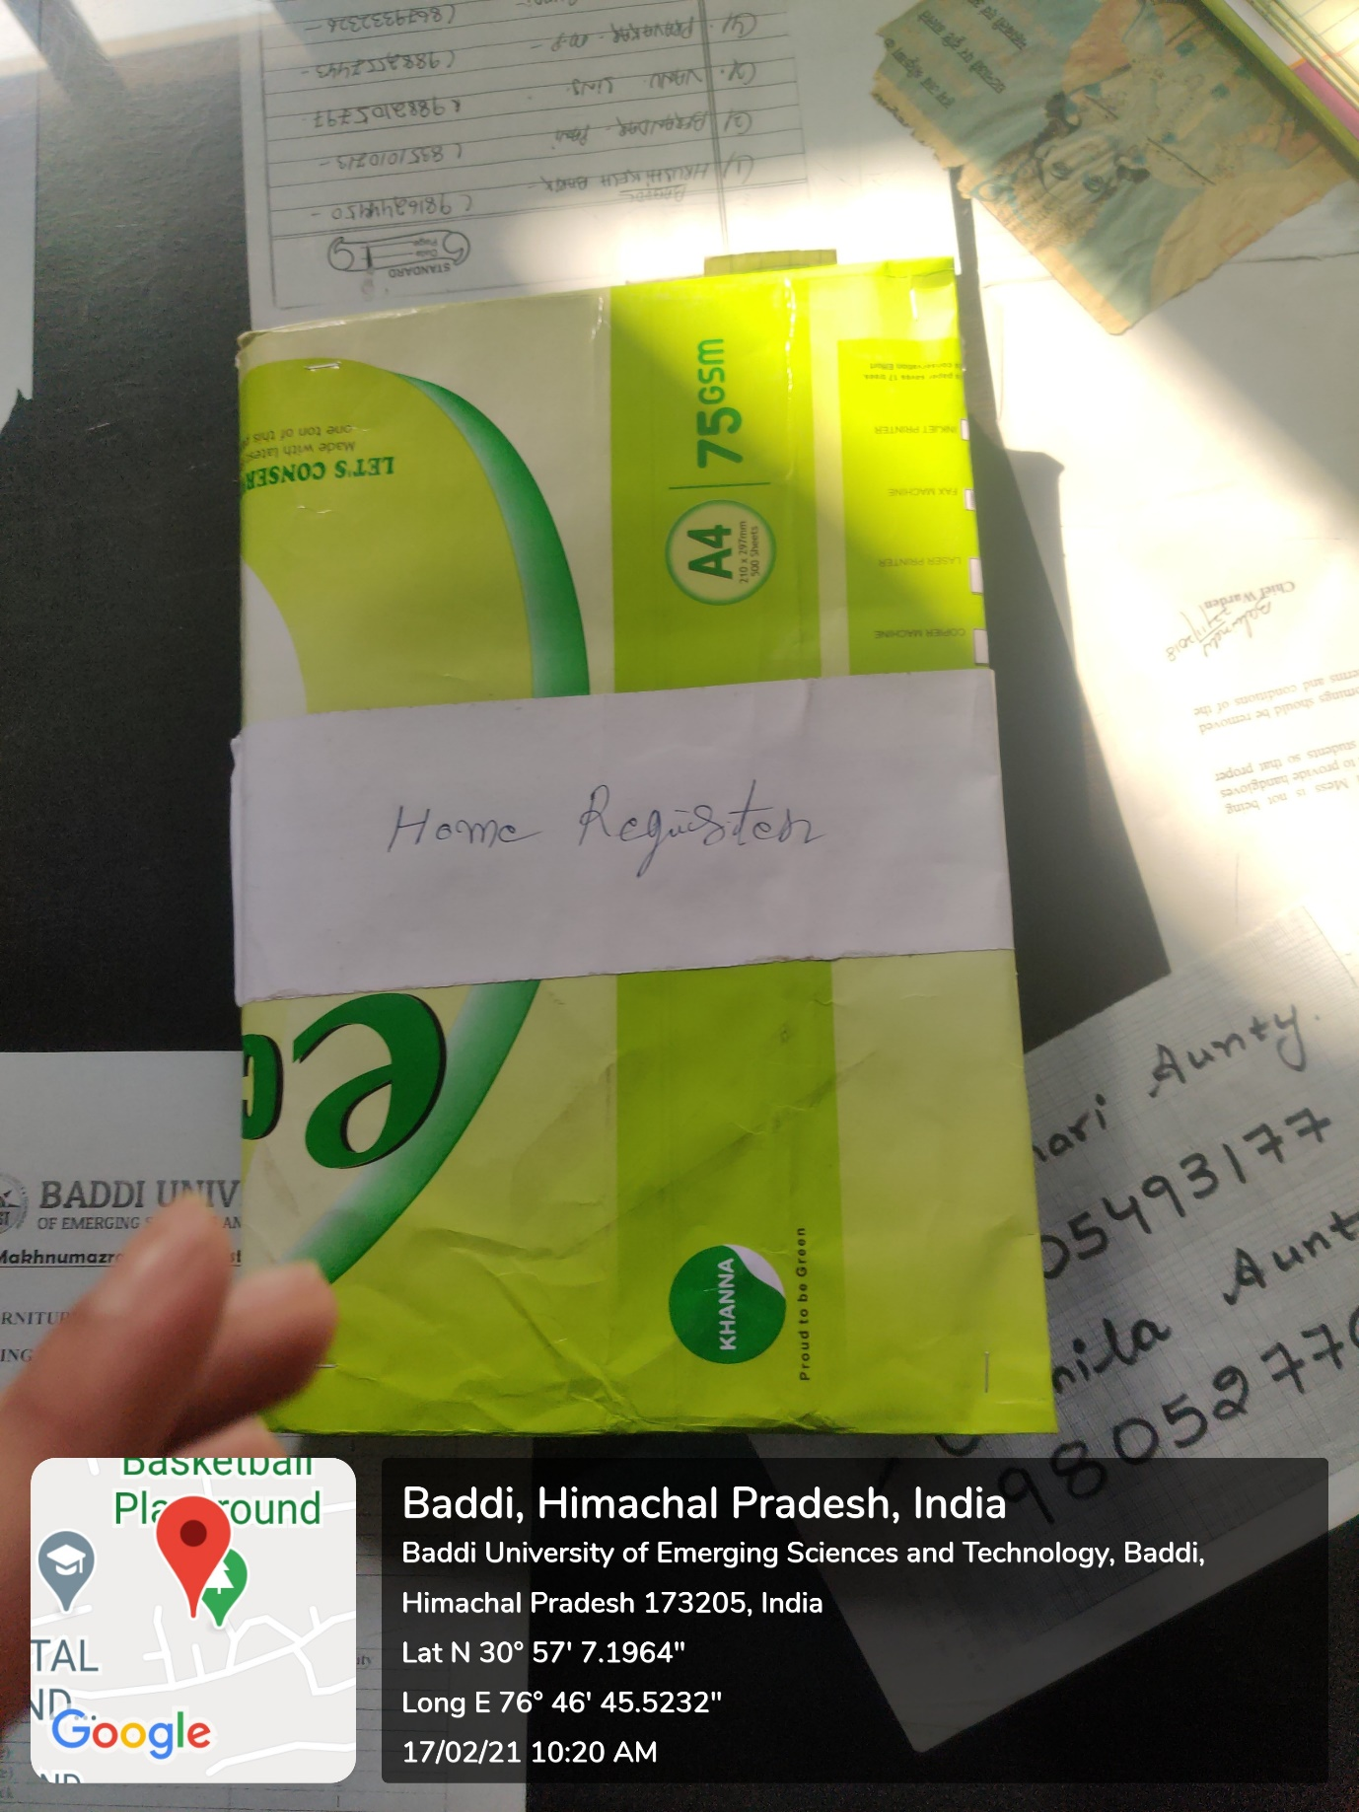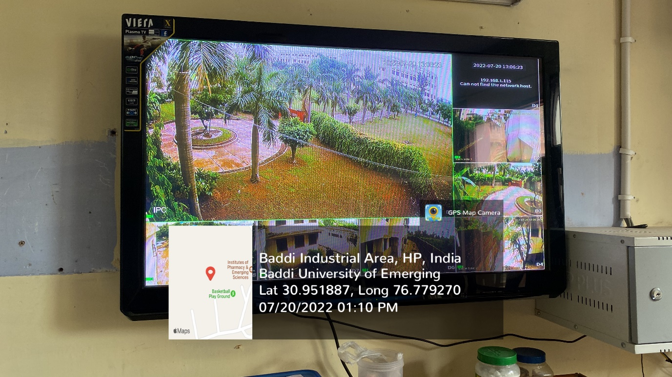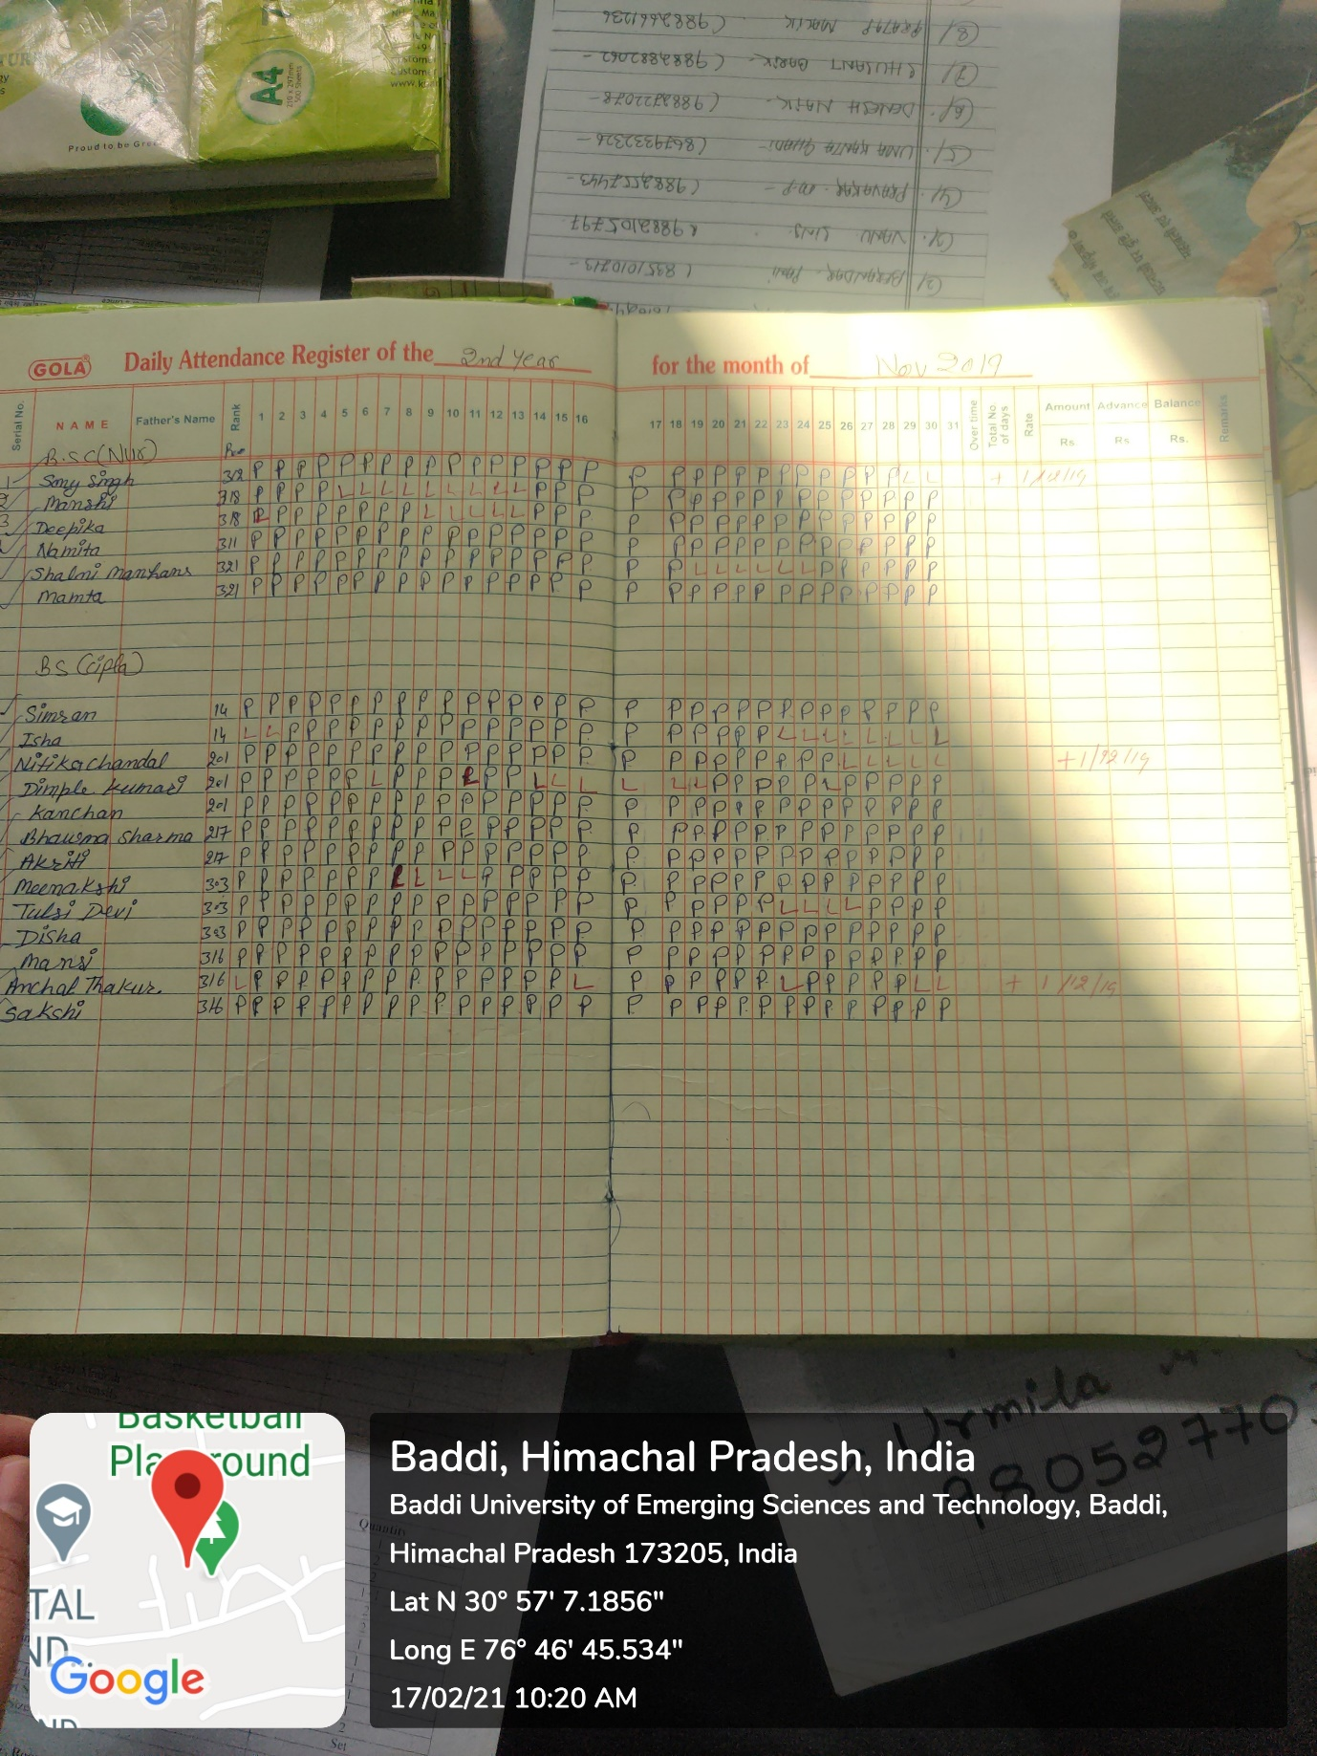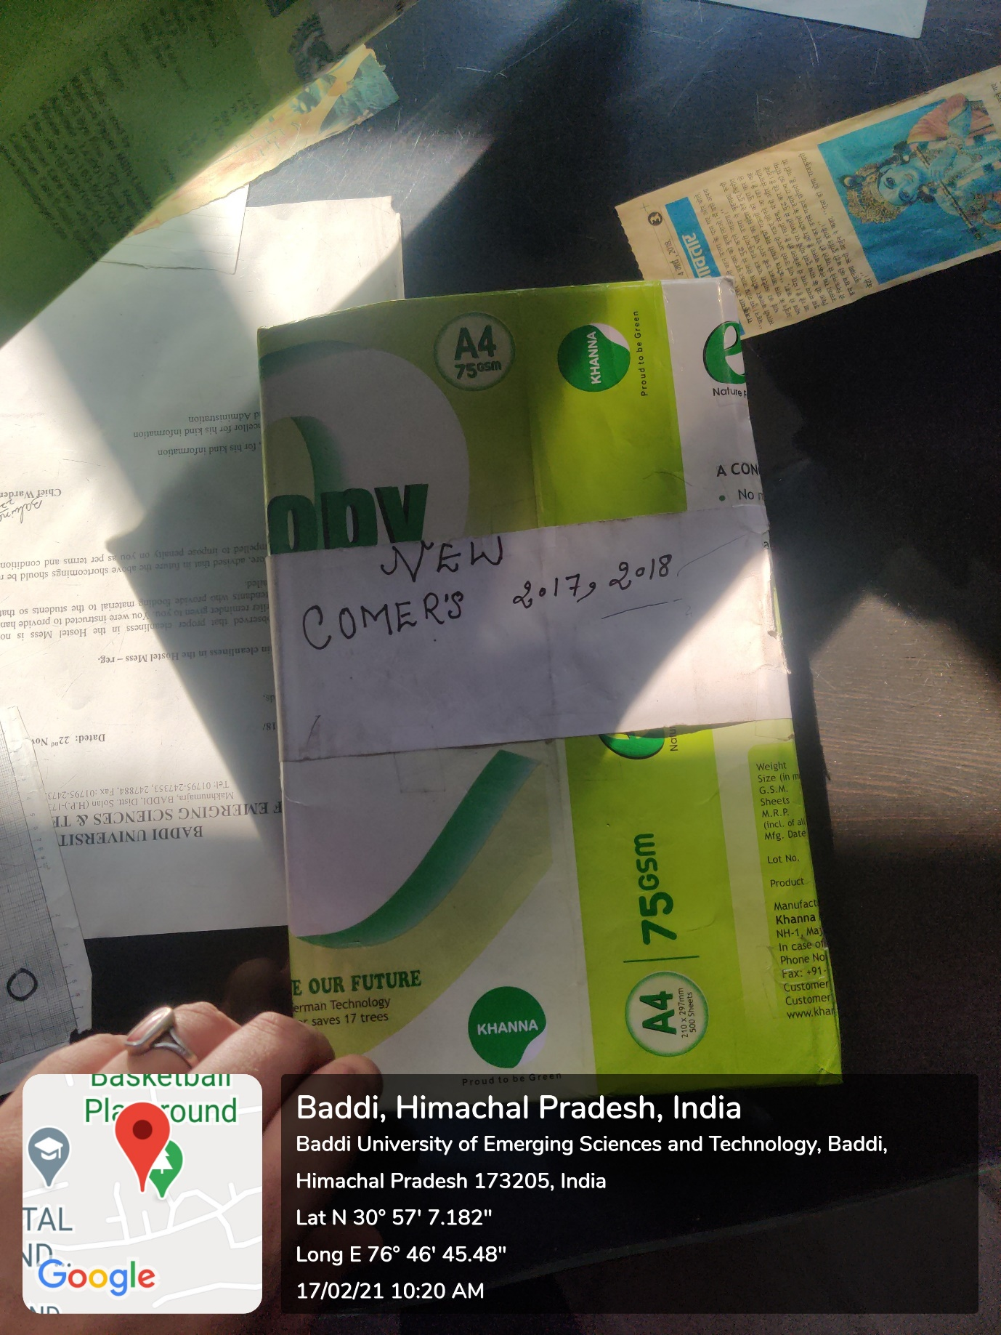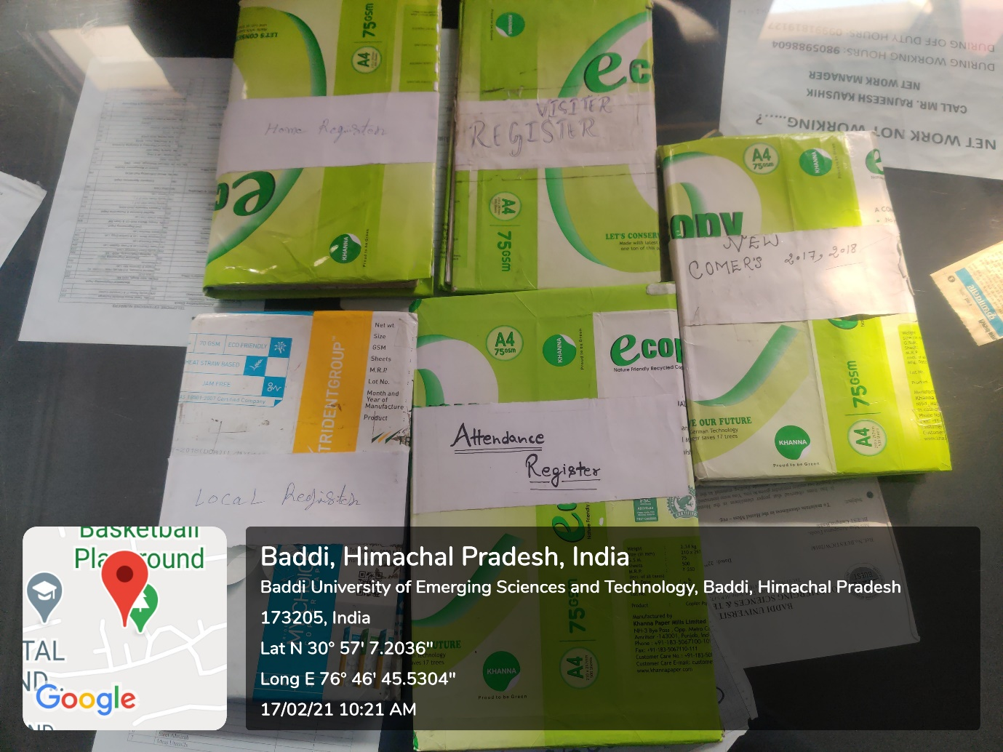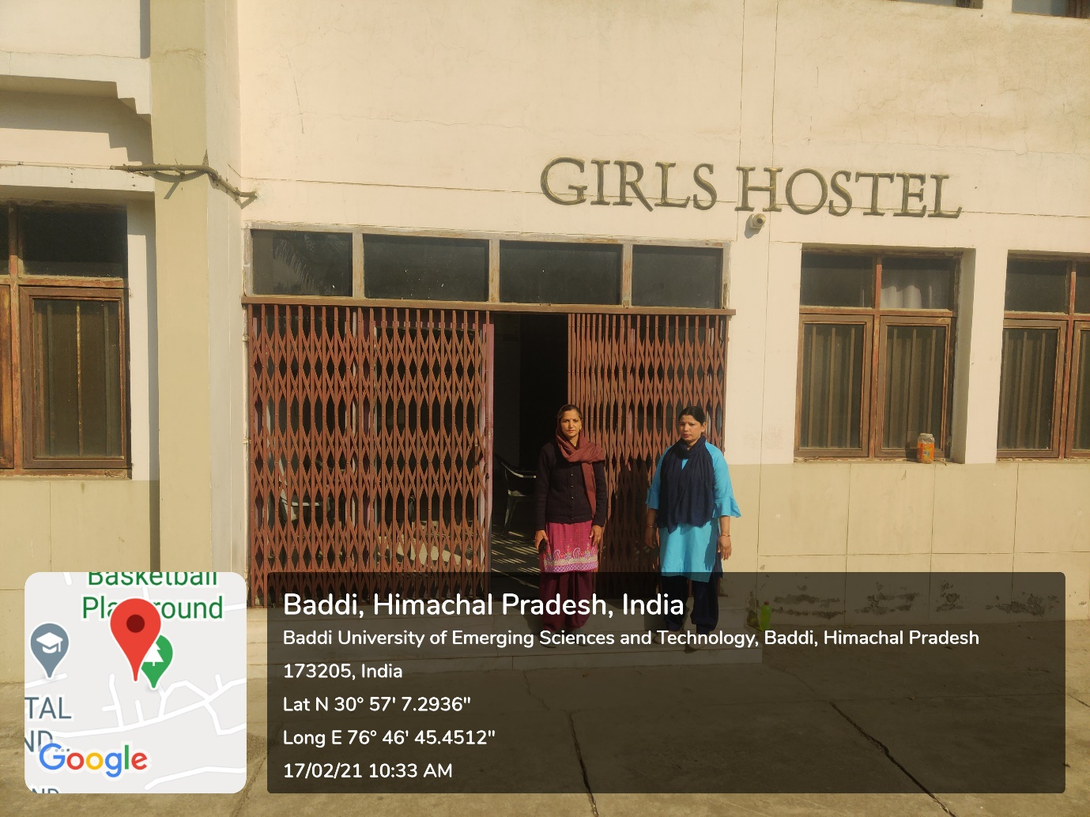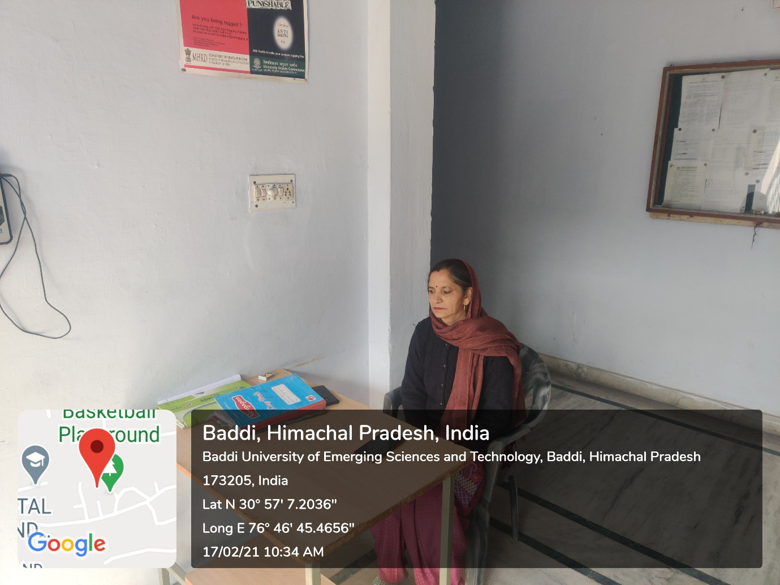

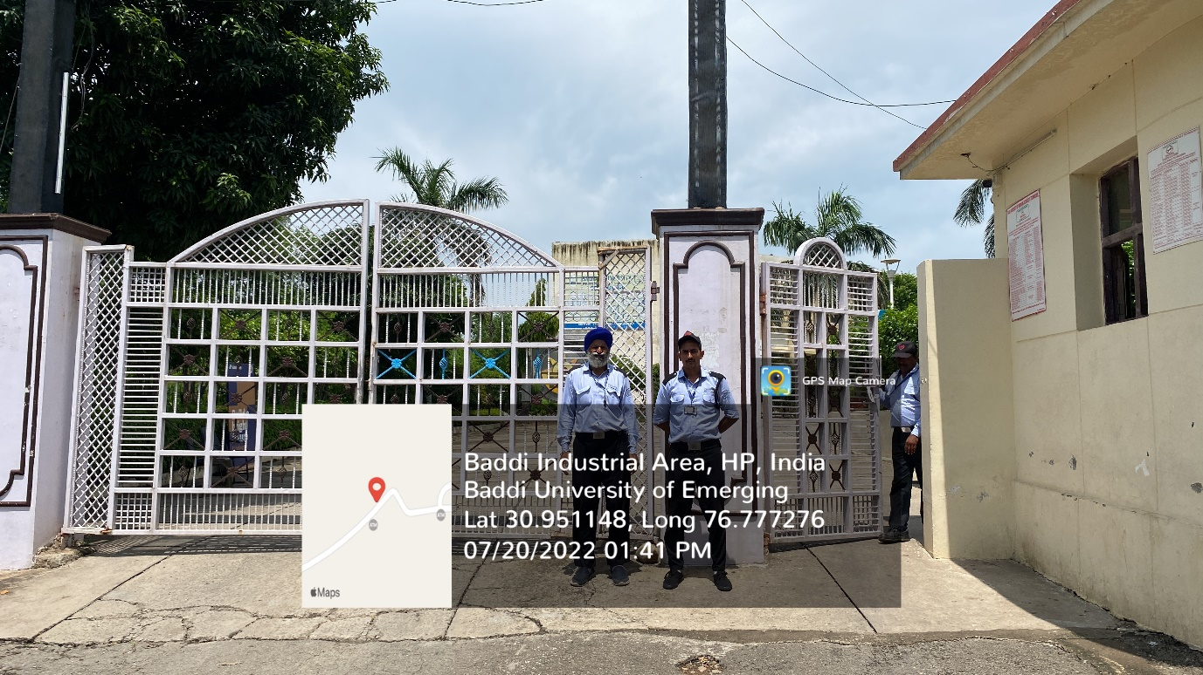
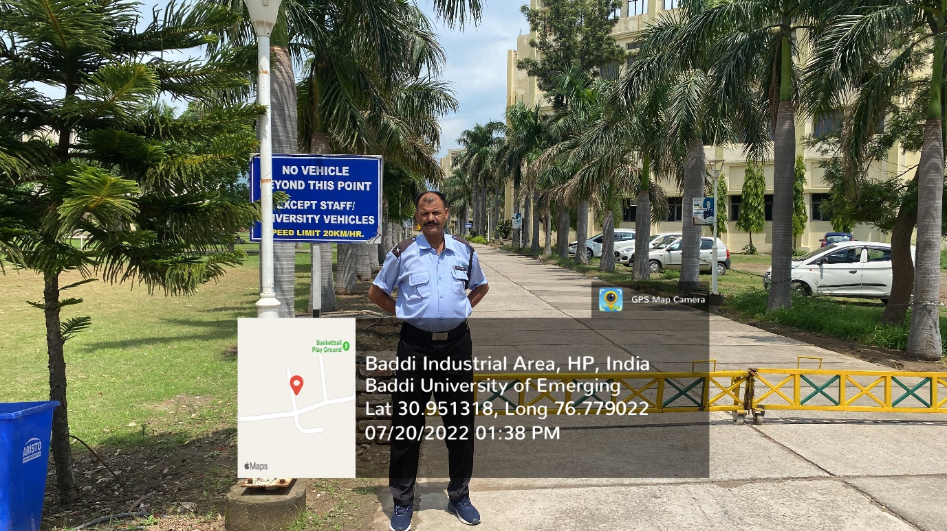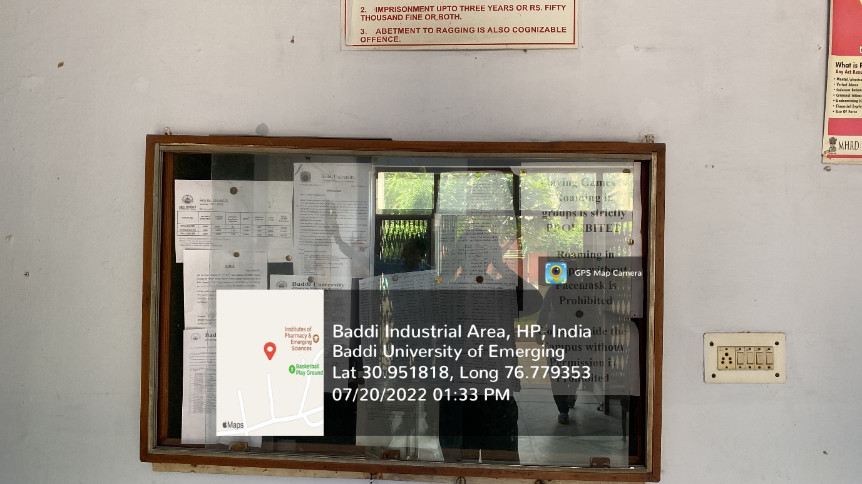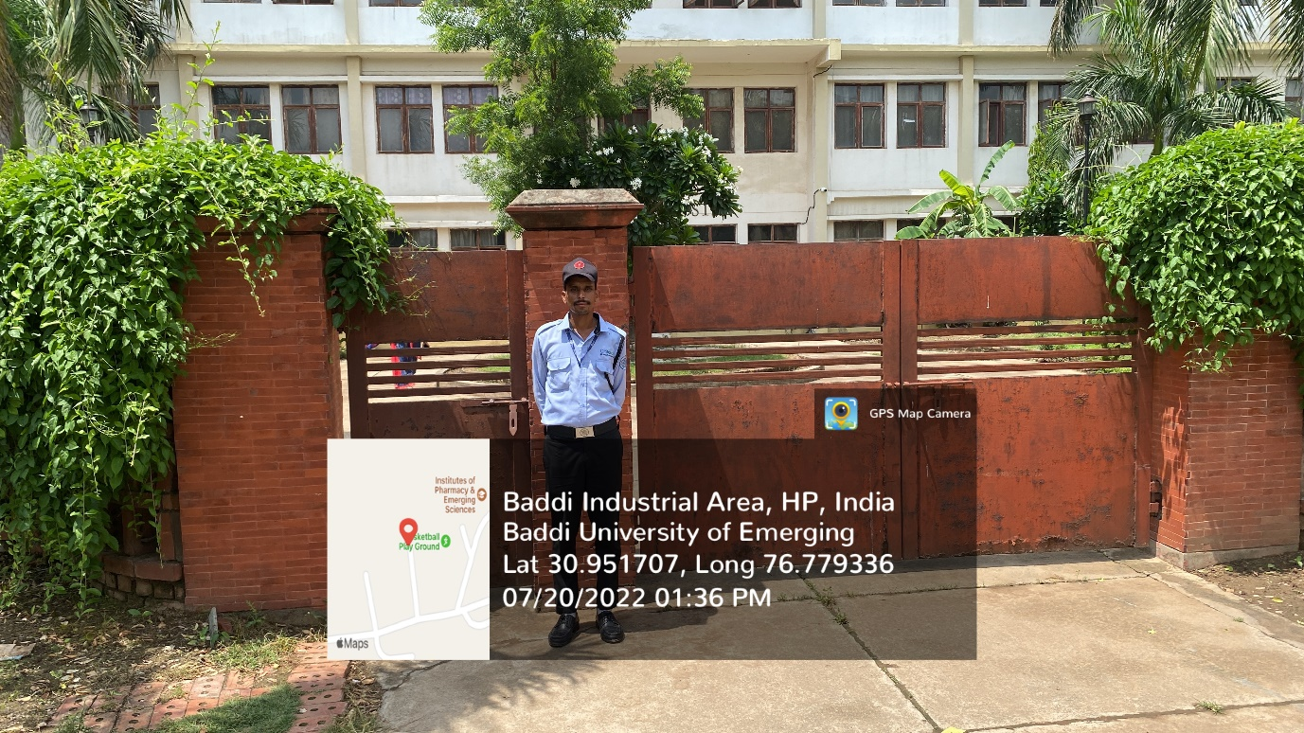
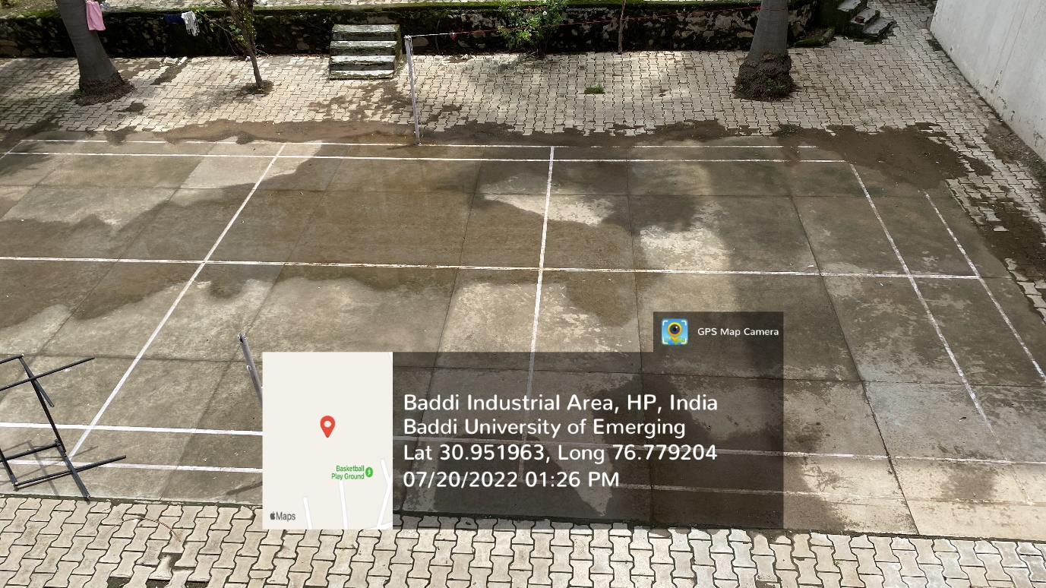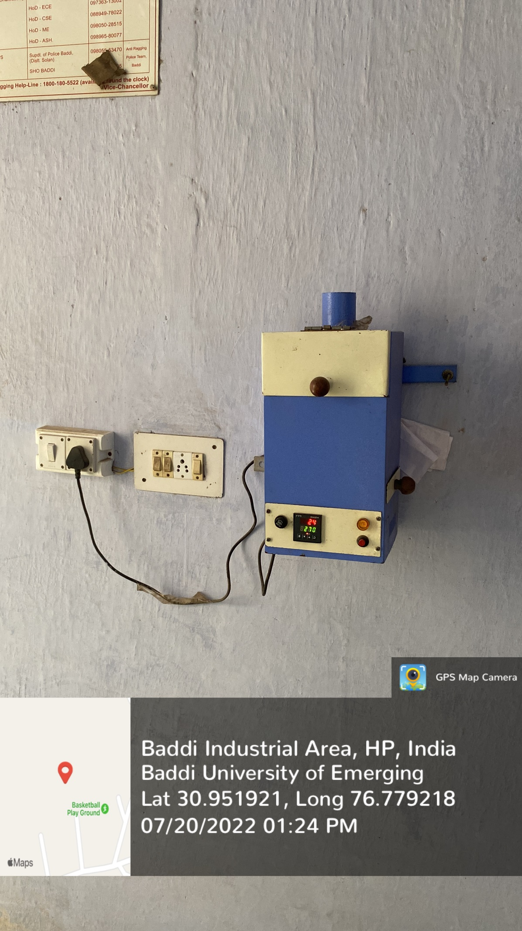
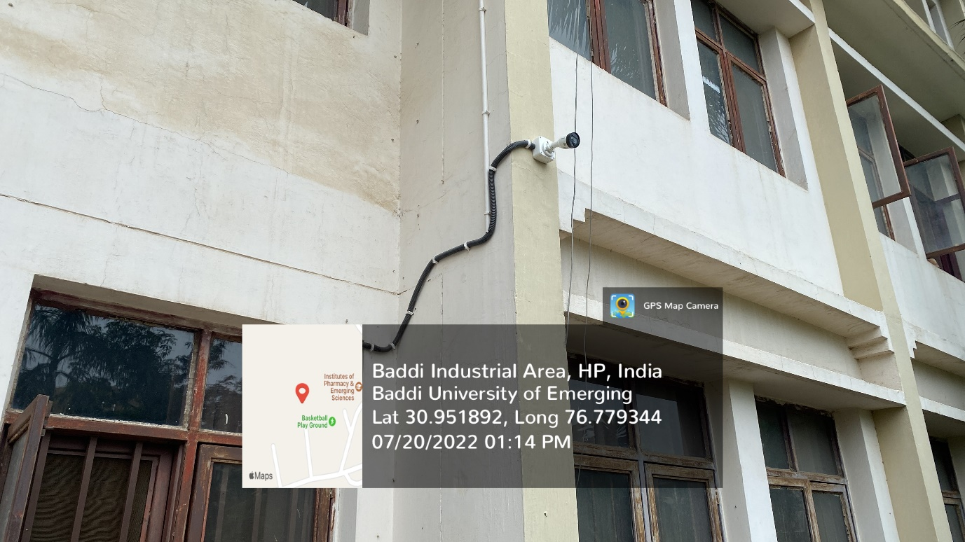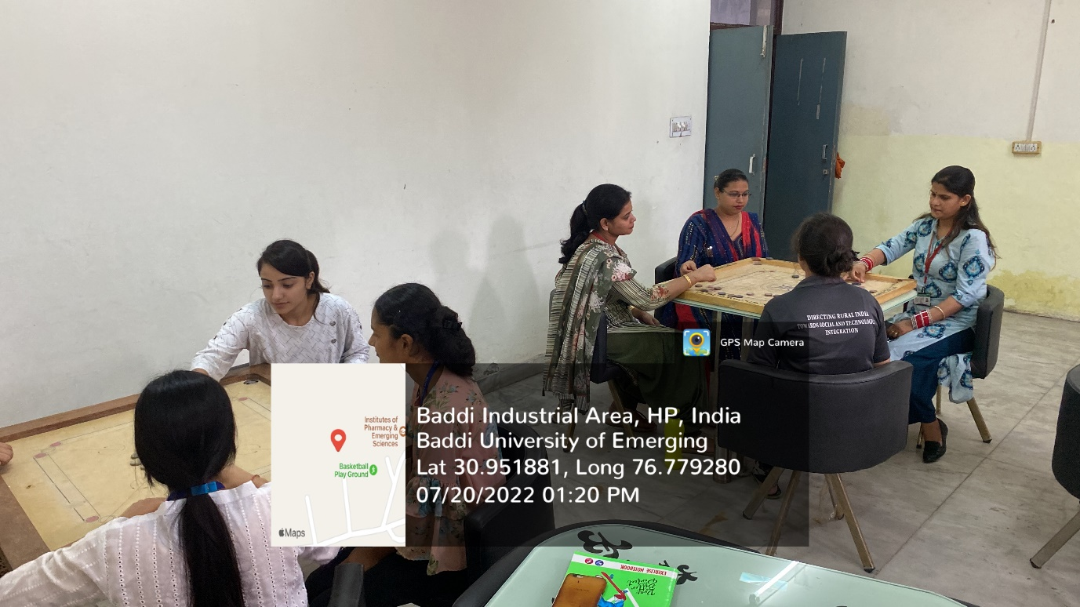

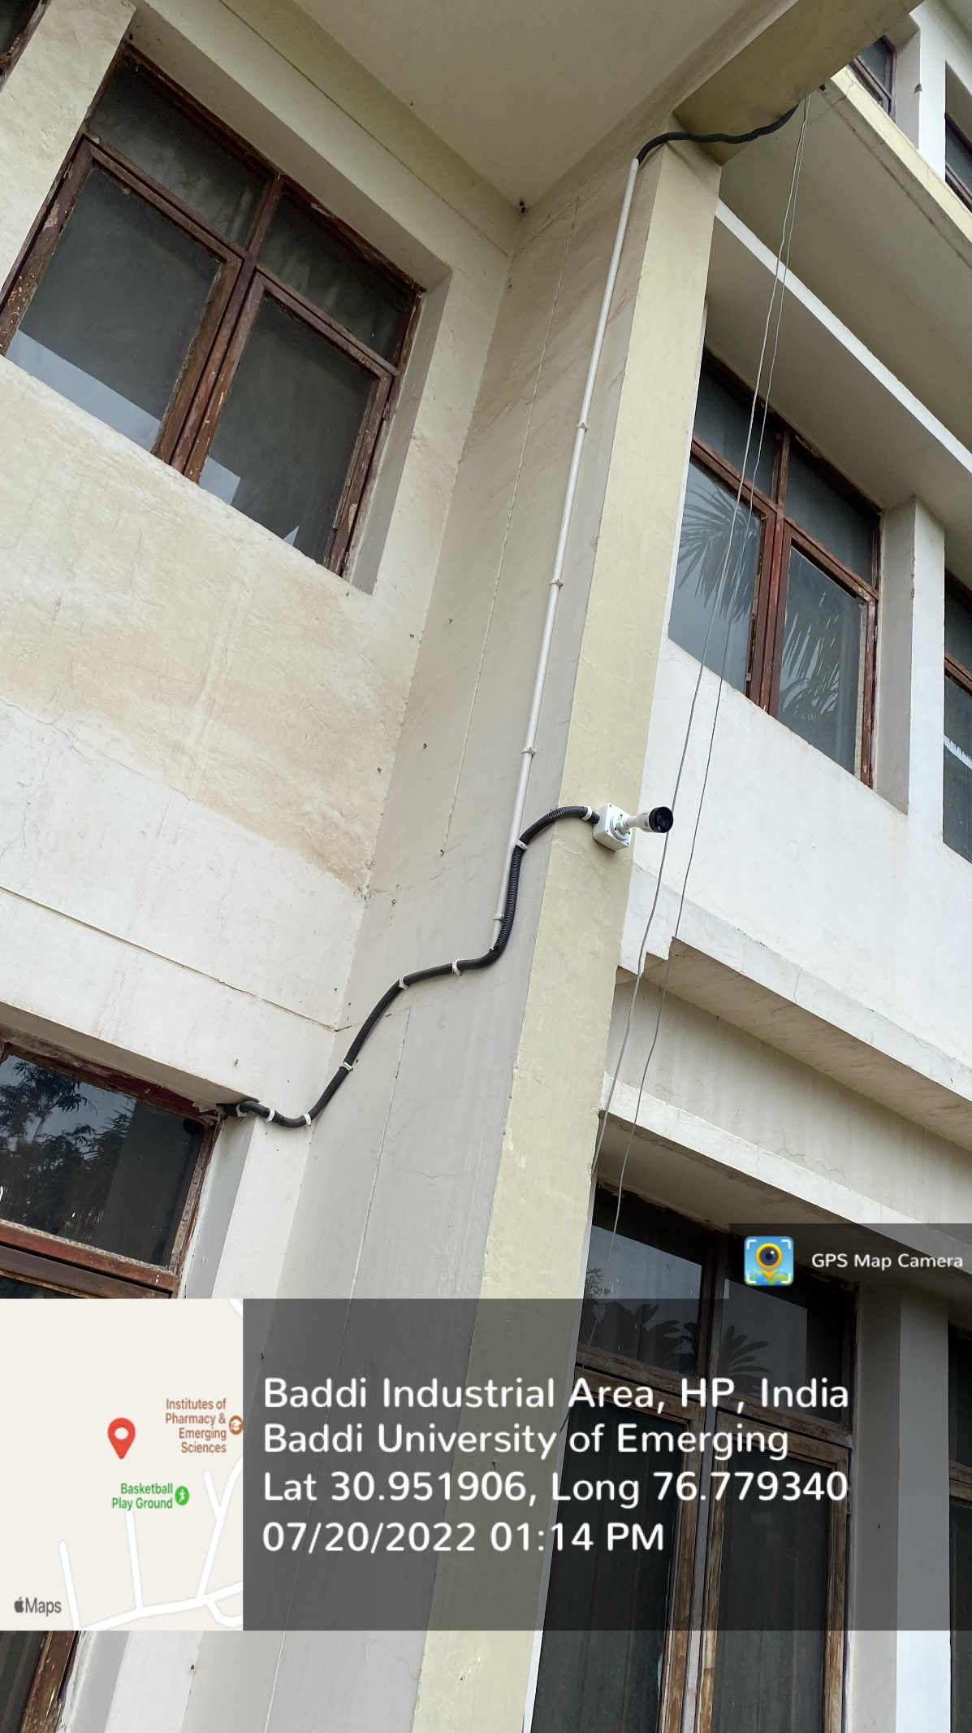

ANTI RAGGING COMMITTEE 2019
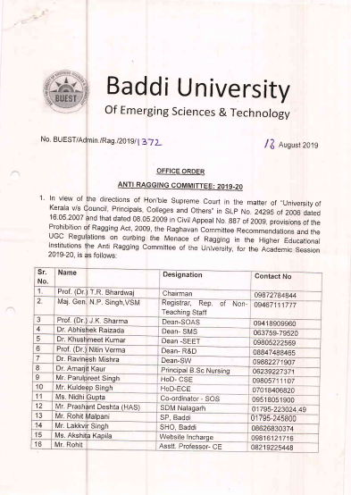
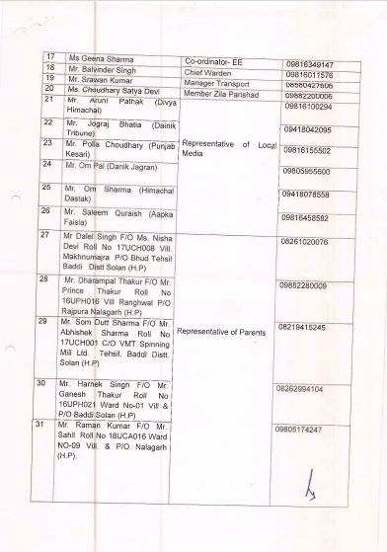

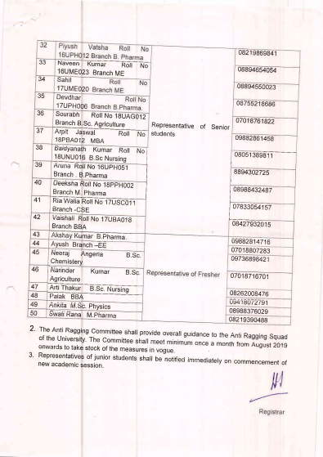

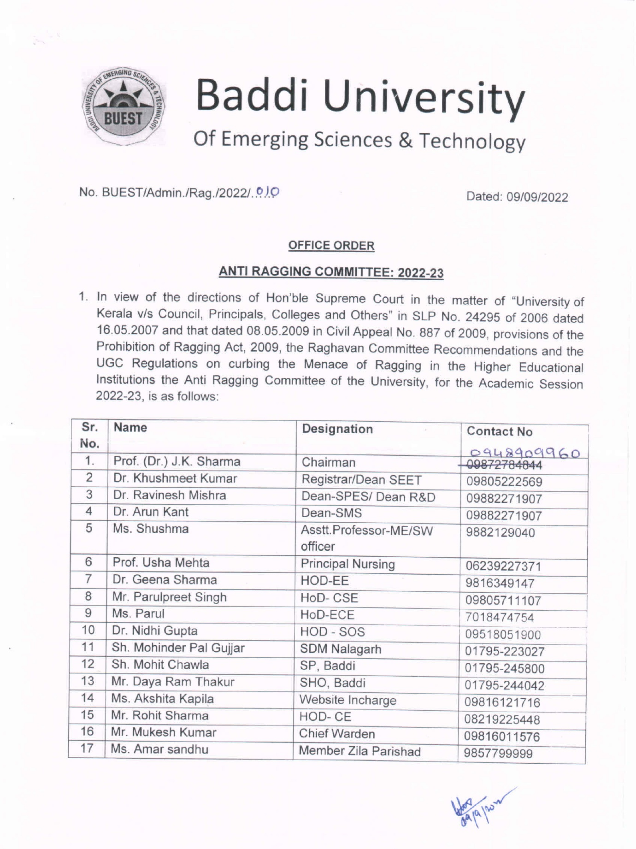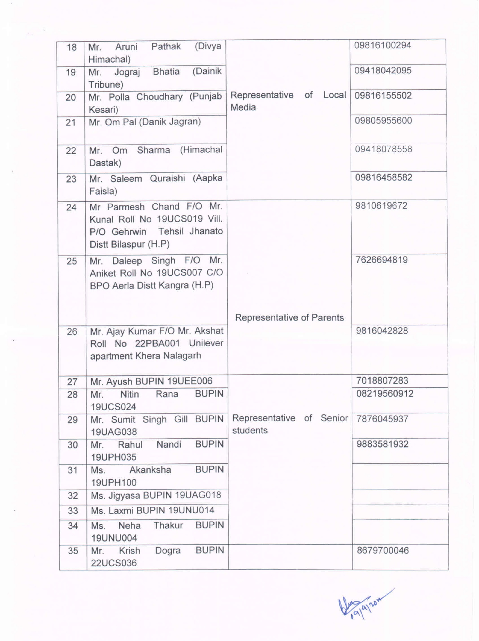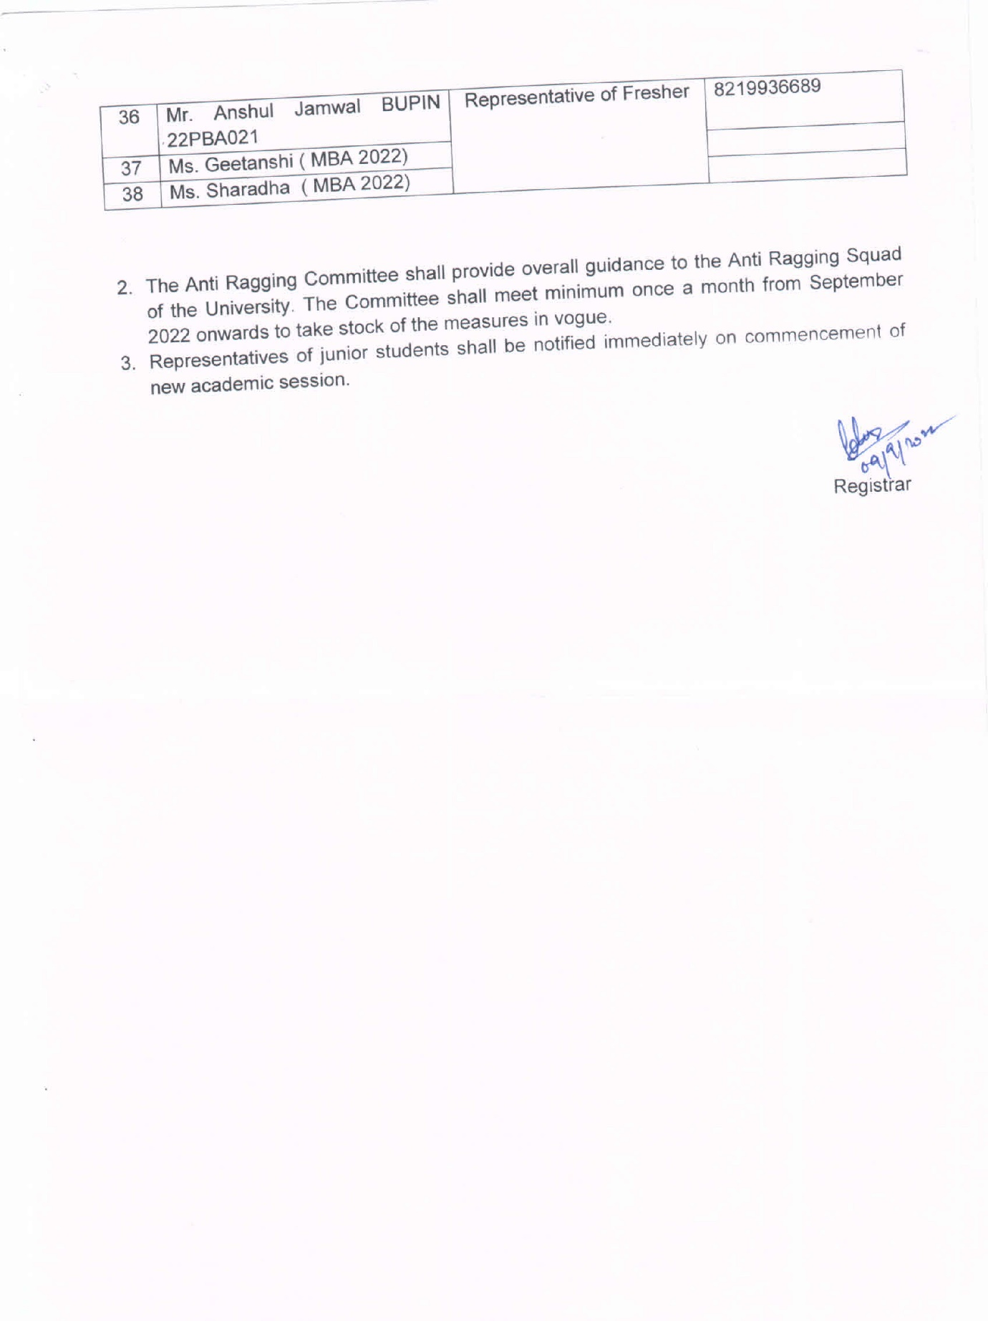

Women Grievance Cell-Cum-Gender Sensitization Committee: 2022-23

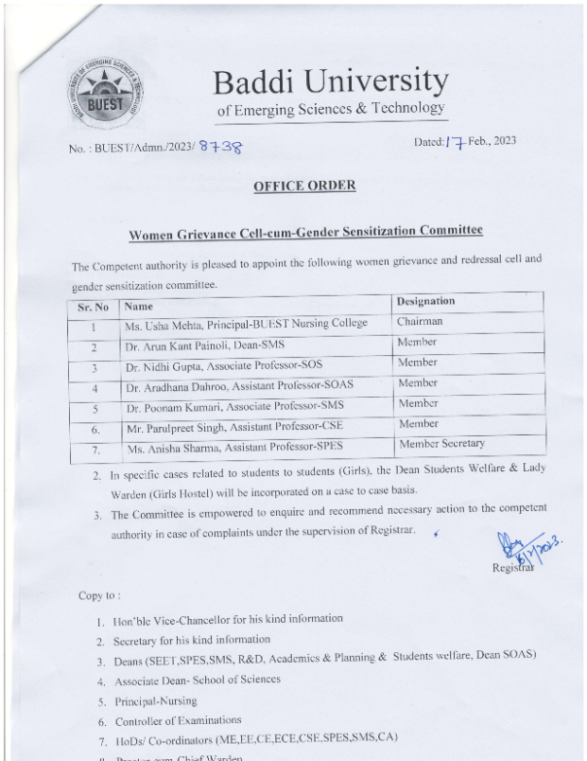

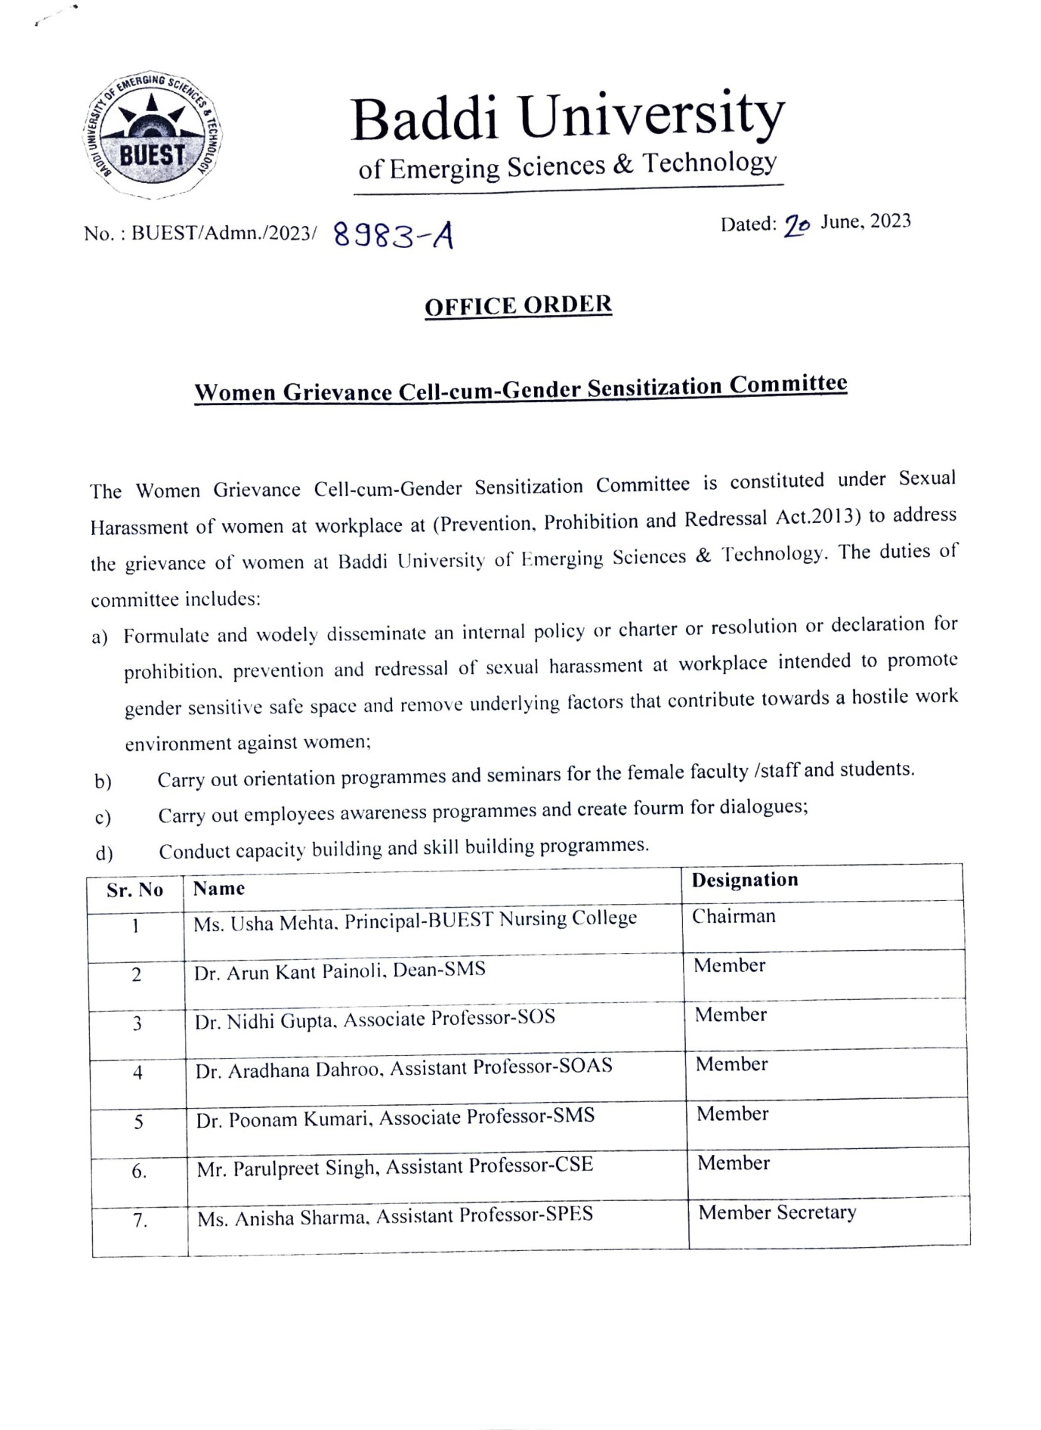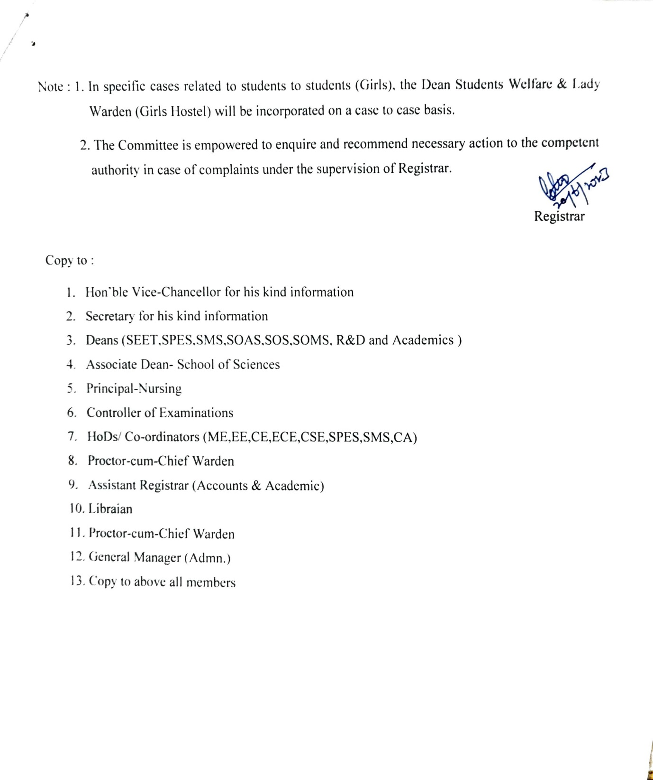

Common Rooms.

